# II. Project Management Plan

## 1. Overview

### 1.1 WBS & Estimation

Table x. WBS & Estimation

|  |  |  |  |
| --- | --- | --- | --- |
| **#** | **WBS Item** | **Complexity** | **Est. Effort** |
| **1** | **Web Application for Admin** |  |  |
| **1.1** | **Manage manager** |  |  |
|  | * Get the managers | Simple | 1 |
|  | * Get the manager detail | Simple | 1 |
|  | * Update the manager | Simple | 1 |
|  | * Delete the manager | Simple | 1 |
|  | * Create the manager | Simple | 1 |
| **1.2** | **Manage store** |  |  |
|  | * Get the stores | Simple | 1 |
|  | * Get the store detail | Simple | 1 |
|  | * Update the store | Simple | 1 |
|  | * Delete the store | Simple | 1 |
|  | * Create the store | Simple | 1 |
| **1.3** | **Manage product** |  |  |
|  | * Get the products | Simple | 1 |
|  | * Get the product detail | Simple | 1 |
|  | * Update the product | Simple | 1 |
|  | * Delete the product | Simple | 1 |
|  | * Create the product | Simple | 1 |
| **1.4** | **Manage camera** |  |  |
|  | * Get the cameras | Medium | 3 |
|  | * Get the camera detail | Medium | 3 |
|  | * Update the camera | Simple | 1 |
|  | * Delete the camera | Simple | 1 |
|  | * Create the camera | Simple | 1 |
| **1.5** | **Manage category** |  |  |
|  | * Get the categories | Simple | 1 |
|  | * Get the category detail | Simple | 1 |
|  | * Update the category | Simple | 1 |
|  | * Delete the category | Simple | 1 |
|  | * Create the category | Simple | 1 |
| **1.6** | **Get the report** | Medium | 3 |
| **1.7** | **Get the video** | Simple | 1 |
| **1.8** | **Reset manager’s account password** | Simple | 1 |
| **1.9** | **Get own profile** | Simple | 1 |
| **1.10** | **Update own profile** | Simple | 1 |
| **1.11** | **Login** | Simple | 1 |
| **1.12** | **Logout** | Simple | 1 |
| **2** | **Web Application for Manager** |  |  |
| **2.1** | **Manage shelf** |  |  |
|  | * Get the shelves | Simple | 1 |
|  | * Get the shelf detail | Medium | 3 |
|  | * Update the shelf | Medium | 3 |
|  | * Delete the shelf | Simple | 1 |
|  | * Create the shelf | Simple | 1 |
| **2.2** | **Manage stack** |  |  |
|  | * Get the stacks | Simple | 1 |
|  | * Get the stack detail | Medium | 3 |
|  | * Update the stack | Medium | 3 |
|  | * Delete the stack | Simple | 1 |
|  | * Create the stack | Simple | 1 |
| **2.3** | **Get the report** | Medium | 3 |
| **2.4** | **Get the video** | Medium | 3 |
| **2.5** | **Upload video** | Complex | 7 |
| **2.6** | **Get own profile** | Simple | 1 |
| **2.7** | **Update own profile** | Simple | 1 |
| **2.8** | **Login** | Simple | 1 |
| **2.9** | **Logout** | Simple | 1 |
| **3** | **Mobile Application for Admin** |  |  |
| **3.1** | **Manage manager** |  |  |
|  | * Get the managers | Simple | 1 |
|  | * Get the manager detail | Simple | 1 |
|  | * Update the manager | Simple | 1 |
|  | * Delete the manager | Simple | 1 |
|  | * Create the manager | Simple | 1 |
| **3.2** | **Manage store** |  |  |
|  | * Get the stores | Simple | 1 |
|  | * Get the store detail | Simple | 1 |
|  | * Update the store | Simple | 1 |
|  | * Delete the store | Simple | 1 |
|  | * Create the store | Simple | 1 |
| **3.3** | **Manage product** |  |  |
|  | * Get the products | Simple | 1 |
|  | * Get the product detail | Simple | 1 |
|  | * Update the product | Simple | 1 |
|  | * Delete the product | Simple | 1 |
|  | * Create the product | Simple | 1 |
| **3.4** | **Manage camera** |  |  |
|  | * Get the cameras | Medium | 3 |
|  | * Get the camera detail | Medium | 3 |
|  | * Update the camera | Simple | 1 |
|  | * Delete the camera | Simple | 1 |
|  | * Create the camera | Simple | 1 |
| **3.5** | **Manage category** |  |  |
|  | * Get the categories | Simple | 1 |
|  | * Get the category detail | Simple | 1 |
|  | * Update the category | Simple | 1 |
|  | * Delete the category | Simple | 1 |
|  | * Create the category | Simple | 1 |
| **3.6** | **Get the report** | Medium | 3 |
| **3.7** | **Get the video** | Medium | 3 |
| **3.8** | **Change manager’s account password** | Simple | 1 |
| **3.9** | **Get own profile** | Simple | 1 |
| **3.10** | **Update own profile** | Simple | 1 |
| **3.11** | **Login** | Simple | 1 |
| **3.12** | **Logout** | Simple | 1 |
| **4** | **Mobile Application for Manager** |  |  |
| **4.1** | **Manage shelf** |  |  |
|  | * Get the shelves | Simple | 1 |
|  | * Get the shelf detail | Medium | 3 |
|  | * Update the shelf | Medium | 3 |
|  | * Delete the shelf | Simple | 1 |
|  | * Create the shelf | Simple | 1 |
| **4.2** | **Manage stack** |  |  |
|  | * Get the stacks | Simple | 1 |
|  | * Get the stack detail | Medium | 3 |
|  | * Update the stack | Simple | 3 |
|  | * Delete the stack | Simple | 1 |
|  | * Create the stack | Simple | 1 |
| **4.3** | **Get the report** | Simple | 3 |
| **4.4** | **Get the video** | Medium | 3 |
| **4.5** | **Get own profile** | Simple | 1 |
| **4.6** | **Update own profile** | Simple | 1 |
| **4.7** | **Login** | Simple | 1 |
| **4.8** | **Logout** | Simple | 1 |
| **5** | **System AI** |  |  |
| **5.1** | **Facial emotion recognition** | Complex | 7 |
| **5.2** | **Statistics number of customers** | Complex | 7 |
| ***Total Estimated Effort (man-days)*** | | | 161 |

### 1.2 Project Objectives

* Timeliness: 70%
* Allocated Effort: 4 (members) * 4 (months) * 21 (days/month) = 336 man-days
* Estimated total cost: 7 million VNĐ

### 1.3 Project Risks

Table x. Project risks

|  |  |  |  |  |
| --- | --- | --- | --- | --- |
| **#** | **Risk Description** | **Impact** | **Possibility** | **Response Plans** |
| 1 | Team cannot find the real factory environment. | Delayed progress. | Medium | Finding and setting up a simulating environment. |
| 2 | Need to research new technologies and solutions. | Delayed progress. | Low | Spending more time learning. |

## 2. Management Approach

### 2.1 Project Process



Figure 1. DevOps lifecycle

***Source:***[*https://www.guru99.com/devops-tutorial.html*](https://www.guru99.com/devops-tutorial.html)

CFFE system is developed using the DevOps model is a simple framework for the most effective coordination among development team members when implementing complex products.

Some reasons why we choose DevOps:

* Easy to learn and use.
* Suitable for small and medium projects.
* Optimize team performance and efficiency.

Continuous DevOps Life-cycle:

* Development
* Testing
* Integration
* Deployment
* Monitoring

### 2.2 Quality Management

* Make rules about clean coding convention to easily manage and support each other.
* Carefully cross-review code.
* Do user testing.

### 2.3 Training Plan

Table x. Training plan

|  |  |  |  |
| --- | --- | --- | --- |
| **Training Area** | **Participants** | **When, Duration** | **Waiver Criteria** |
| Machine Learning basic | All member | Week 1, 7 days | Mandatory |
| Git, Github | All member | Week 2, 3 days | Mandatory |
| Flutter | All member | Week 3, 5 days | Mandatory |
| VueJS | All member | Week 3-4, 7 days | Mandatory |

## 3. Master Schedule

***Note:*** *Effort unit is day*

Table x. Master schedule

|  |  |  |  |  |
| --- | --- | --- | --- | --- |
| **#** | **Deliverable** | **Effort** | **Due Date** | **Deliverable Scope** |
| 1 | Project Plan document | 5 | 06/06/2021 | Overall project plan |
| 2 | SRS documents | 15 | 24/06/2021 | Software requirements |
| 3 | Design documents | 20 | 13/07/2021 | Architecture design, Detailed design, Database, UI design |
| 4 | Crack detection | 25 | 25/08/2021 | Code, System test cases |
| 5 | Web application | 18 | 05/08/2021 | Code, System test cases |
| 6 | Mobile application | 20 | 10/08/2021 | Code, System test cases |
| 7 | Final code package | 5 | 15/08/2021 | Code, System test cases |
| 8 | Test reports | 5 | 18/08/2021 | Code, System test reports |
| 9 | Guides documents | 5 | 20/08/2021 | Installation guides, User manual guilds |
| 10 | Final project package | 5 | 24/08/2021 | Final codes & documents, User manual |

## 4. Project Organization

### 4.1 Team & Structures

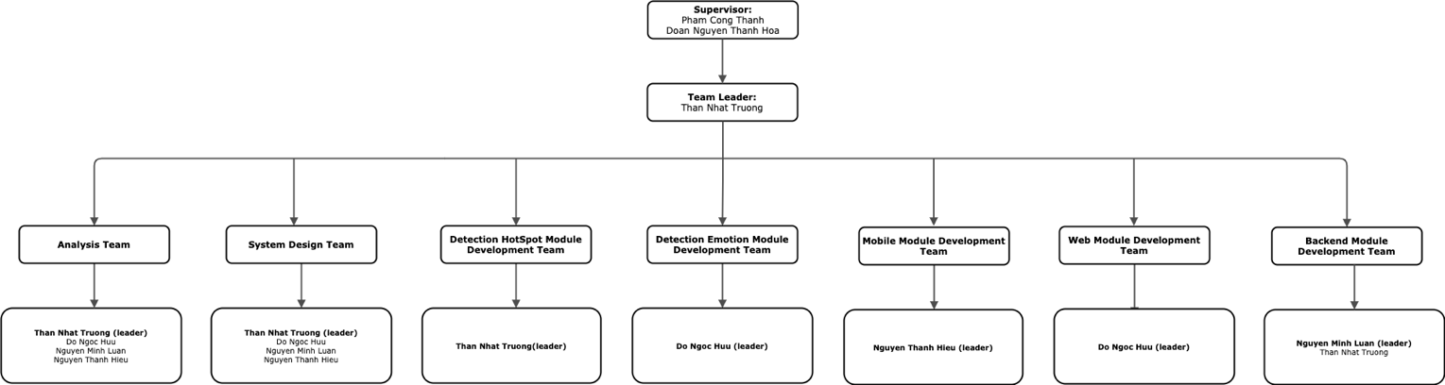

Figure 2. Team structures

### 4.2 Roles & Responsibilities

|  |  |
| --- | --- |
| **Role** | **Responsibility** |
| Project Manager | * Specify user requirements. * Specify system’s features. * Support team in technical and business analysis. |
| Team Leader | * Plan projects and assign tasks to team members. * Support members to complete tasks on time. |
| Analysis Team | * Analyses user requirements and business rules. * Research other directions to promptly change and correct. |
| System Design Team | * Determine the appropriate architecture for the property of the project. * Outline the goals of the project. * Propose solutions to meet the given objectives. |
| Mobile Module Development Team | * Implement user interface. * Implement code for management. |
| Web Module Development Team | * Implement user interface. * Implement code for management. |
| Detection HotSpot Module Development Team | * Implement code for hotspot detection. |
| Detection Emotion Module Development Team | * Implement code for emotion detection. |
| Backend Module Development Team | * Implement code for backend API. |

## 5. Project Communication

## 5.1 Communication Plan

Table x. Communication plan

|  |  |  |  |  |
| --- | --- | --- | --- | --- |
| **Communication Item** | **Who/ Target** | **Purpose** | **When, Frequency** | **Type, Tool, Method(s)** |
| Working in group | Team members | * Improve group solidarity. * Members with good skills can train other members. * Discuss and work together to help each other | 6 days per week | Face to face, Online |
| Mentoring | Team members and Mentors | * Review team’s work progress. * Give advice and direction. * Technical support. | 3, 4 times per week | Face to face, Online |

### 5.2 External Interface

#### a. FU Contacts

Table x. FU contacts

|  |  |  |  |
| --- | --- | --- | --- |
| **Function** | **Contact Person**  **(name, position)** | **Contact address**  **(email, telephone)** | **Responsibility** |
| Supervisor | Phạm Công Thành  Đoàn Nguyễn Thành Hòa |  | * Provide document template. * Give instruction to project team. * Review deliverables. * Supervise project status |

### 6. Configuration Management

### 6.1 Tools & Infrastructures

Table x. Tools & Infrastructures

|  |  |
| --- | --- |
| **Programming languages** | **Java, Javascript, Dart, Python** |
| Framework | Spring Boot, MyBatis, VueJS, Flutter, Tensorflow, Keras |
| API | OpenAPI |
| DBMS | MySQL |
| IDEs/Editors | IntelliJ, Visual Studio Code |
| UML tools | Draw.io, StarUML |
| Version Control | Git |
| Deployment server | Google Compute Service |
| Project management tool | Trello |

### 6.2 Document Management

Use Google Shared Drives and Trello to manage easily.

### 6.3 Source Code Management

Use Git.

# IV. Software Design Description

## 5. Algorithms & Research

### 5.1 Detection “HotSpot”

#### a. Problem definition

Import a video and count the number of people cross the line.

#### 

#### b. Requirement

* + Detecting time is not too long.
  + Almost all people cross the line who are counted.

#### c. Solution

We divide solution into 2 main parts:

* + **Object Detector** is using to determine coordinate of the people.
  + **Tracking Object** is using to track peoples from the determined coordinates.

1. **Object Detector**

* We choose SSD300(VGG16) pre-trained model to determine coordinate of the people.
* Advantages of SSD300(VGG16) pre-trained model:
  + Save time to train model.
  + Detecting time and accuracy is better than other models.
  + SSD300(VGG16) pre-trained model:
    - Mean accuracy is 74.3% and speed is 46 fps.
    - The SSD (Single Shot Multi Box Detector) architecture is based on a feed forward convolutional network.
    - VGG16 is a convolutional neural network model.
    - SSD300(VGG16) architecture include:
      * Using VGG16 Base Network
      * Layers of the SSD Model with the input layer size is 300x300
      * Apply feature maps with different sizes.
      * Prediction through the convolutional network for object.
      * Default box and aspect ratio.



Figure x. SSD300(VGG16) Architecture

1. **Tracking Object**

After Object Detector we have coordinates of the people. Then we start to tracking object process with 5 steps:

* Step 1: Compute centroids from box coordinates:

The centroid tracking algorithm assumes that we are passing in a set of the bounding box (x, y)-coordinates for each detected object in every single frame. Then, we compute the centroid or the center (x, y)-coordinates from box coordinates follow by formula:

($x_{centriod}$, $y_{centriod}$) $=(\frac{x_{end}-x_{start}}{2}$, $\frac{y_{start}-y_{end}}{2})$



Figure x: Step 2 in Tracking Object Algorithm.

* Step 2: Compute distance between new and existing objects:

From every subsequent frame we compute in Step #1; we need to determine if we can associate the new object centroids (yellow) with the old object centroids (purple). We compute the Euclidean distance (highlighted lines) between each pair of existing object centroids and input object centroids.

Euclidean distance formula: In two dimensions, let 2 point $p\left(p_{1}, p_{2}\right), q\left(q_{1}, q_{2}\right)$. The distance between p and q given by:

$$d\left(p,q\right)= \sqrt{{\left(q_{1} -p_{1}\right)}^{2}+{\left(q_{2}-p_{2}\right)}^{2}}$$



**Figure x: Step 2 in Tracking Object Algorithm**

* Step 3: Update *(x, y)*-coordinates of existing objects

The primary assumption is a given object will potentially move in between subsequent frames, but the distance between the centroids for frames $F_{t}$ and $F_{t+1}$ will be smaller than all other distances between objects. So, if we choose to associate centroids with minimum distances between subsequent frames we can build our object tracker.

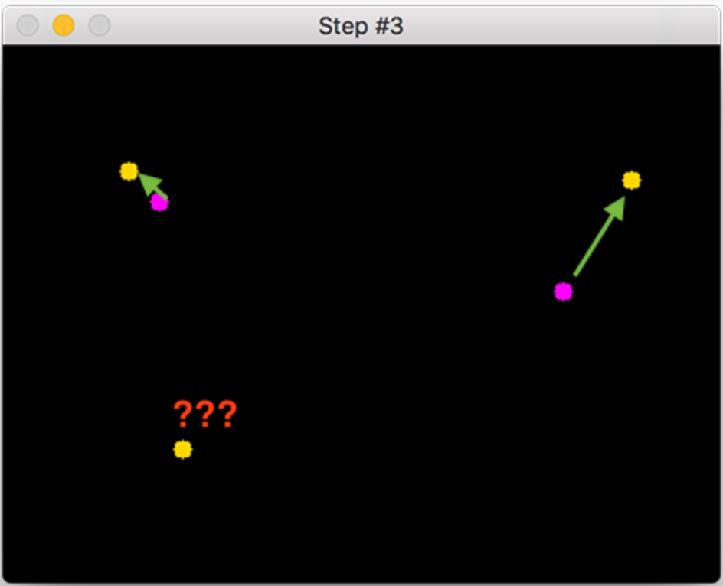

Figure x: Step 3 in Tracking Object Algorithm

* Step 4: Register new objects
* Step 5: Deregister old objects

# VI. Release Package & User Guides

## 1. Deliverable Package

### 1.1 Source codes & documents

Table xx. Source codes & documents

|  |  |  |
| --- | --- | --- |
| **No** | **Items** | **Sub-Items** |
| **Code packages** | | |
| 1 | CFFE.CapstoneBE.zip |  |
| 2 | CFFE.CapstoneFE.zip |  |
| 3 | CFFE.Mobile.apk |  |
| **Databases** | | |
| 1 | Script | capstone.sql |

### 1.2 Known Issues, Limitations & Restrictions

## 2. Installation Guides

### 2.1 System Requirements

#### a. Back End Server requirements:

* Tested OS: RedHat 8 or above.
* Network: LAN, Internet access capability.
* Hardware configurations:

Table xx. Back End Server – Recommended hardware configuration

|  |  |  |  |
| --- | --- | --- | --- |
| **Type** | **Part/Component** | **Minimum** | **Recommended** |
| Computer | OS supported | RedHat | _ |
| Computer | Network | Internet | _ |
| Computer | RAM | 2GB | > 2GB |
| Computer | Cluster | 4 machines | 8 machines |
| Computer | Storage Space | 50GB | >50GB |
| Computer | Ports | Network | _ |

* Software requirements:
  + Java SE Development Kit 8: JDK 8u281
  + Apache Maven 3.6.3
  + MySQL 8.0
  + Python3.8.2

#### b. Web Server requirements

* Tested OS: RedHat 8 or MacOS.
* Network: LAN, Internet access capability.
* Hardware configurations:

Table xx. Back End Server – Recommended hardware configuration

|  |  |  |  |
| --- | --- | --- | --- |
| **Type** | **Part/Component** | **Minimum** | **Recommended** |
| Computer | OS supported | RedHat | _ |
| Computer | Network | Internet | _ |
| Computer | RAM | 2GB | > 2GB |
| Computer | Cluster | 4 machines | 8 machines |
| Computer | Storage Space | 50GB | >50GB |
| Computer | Ports | Network | _ |

* Software requirements:
  + Nodejs
  + Vue3

### 2.2 Environment setup requirements

* Operating system: RedHat 8.
* Java SE Runtime 8.
* Soft wares: MySQL 8.0.

### 2.3 Setup Files

* CFFE.CapstoneBE.zip: API for applications.
* CFFE.CapstoneWeb.zip: Web for Module Web.
* CFFE.CapstoneDetect.zip: Detect for Module Detect.
* CFFE.Mobile.apk:APK mobile for android*.*

### 2.4 Installation Instruction

#### a. Setup environment

##### 1. Setup and start a RedHat OS (RedHat 8 or above)**.**

**1.** Open browser and go to this URL: [Console Google Cloud](https://console.cloud.google.com/) then Login in with **Google account**



Figure xx. Login GCP form

**2.** Create a VM Instance with Red Hat Enterprise Linux 8:

1. Further information: Go to this URL [Create a Linux VM Instance | GCP](https://cloud.google.com/compute/docs/quickstart-linux)

2. Fill information and choose Boot Disk is Red Hat Enterprise Linux 8 image (1). Then, click “Create” Button (2).

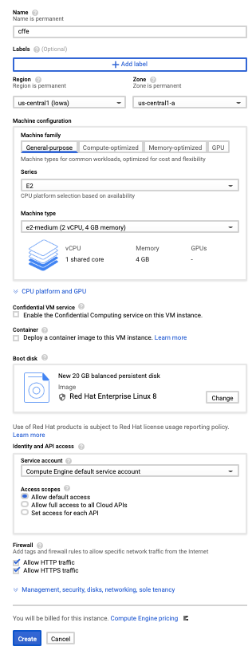

2

1

Figure xx. Choose configs VM

##### 2. Install Java Development Kit, Apache Maven, Python, NodeJS, MySQL

1. Connect Linux VM Instance. Further information: [Connecting to Linux VM Instance | GCP](https://cloud.google.com/compute/docs/instances/ssh#console)

2. Run an install script file:

1. Run as root user with this command: **sudo su –**



Figure xx. Run as root user

2. Prepare a “InstallModules.sh” file with this content:



Figure xx. “InstallModules.sh” file contents.

3.Start to install environment: **yes y | source ./InstallModules.sh**



Figure xx. Run the bash script file

4. Reload bash file system with this command: **source ~/.bashrc**



Figure xx. Reload the config bash file

5. Verification modules installed with commands:

* Check installed JDK (1): **java -version**
* Check installed Apache Maven (2): **mvn –version**
* Check installed Python (3): **python3.8 --version**
* Check installed NodeJS (4): **node –version**
* Check installed MySQL (5): **mysql –version**
* Check MySQL active status (6): **systemctl status mysqld.service**

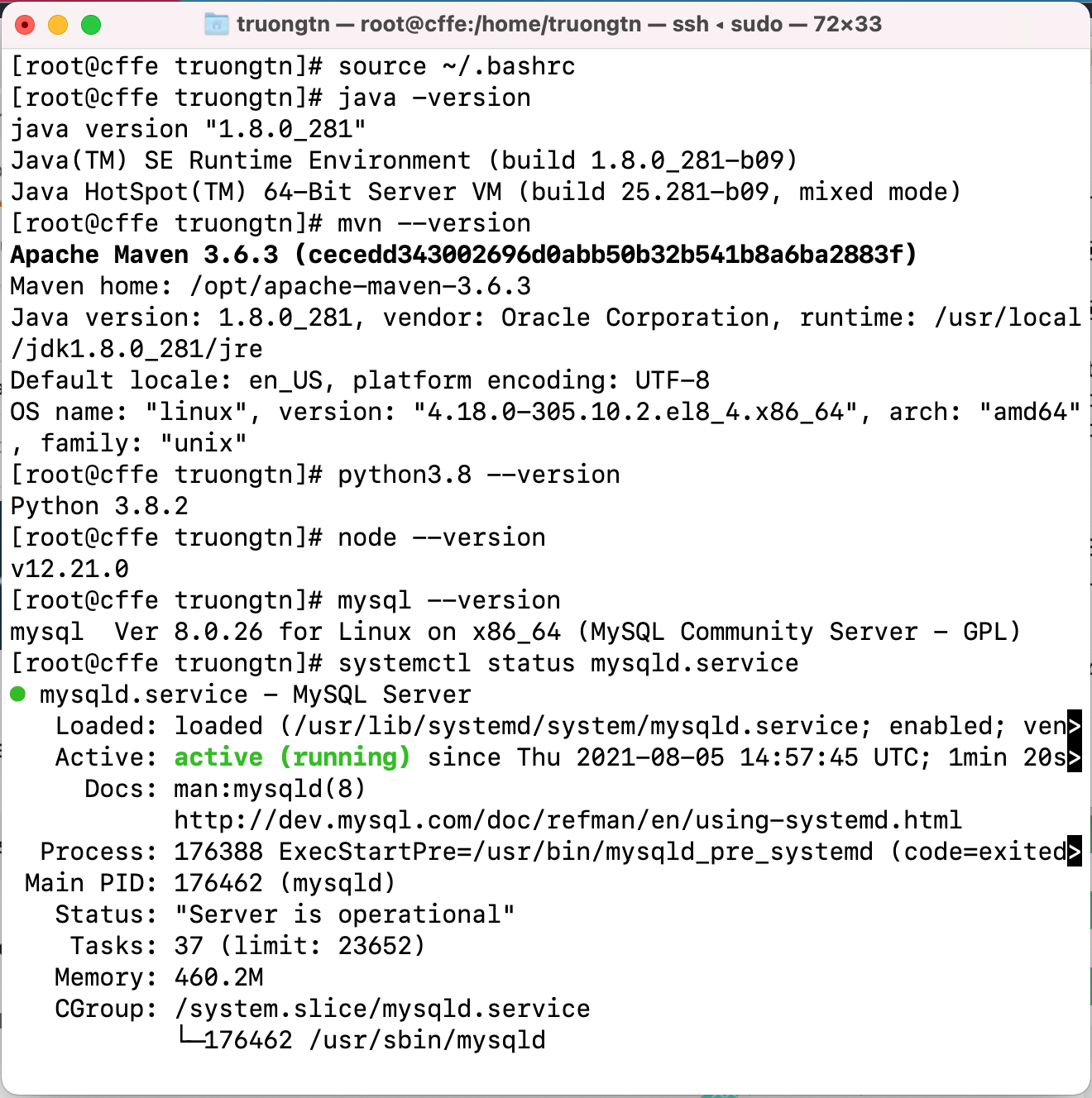

6

5

4

3

2

1

Figure xx. Validate installed module

6. Check “CFFE_SYSTEM.zip” file is downloaded with this command: **ls**

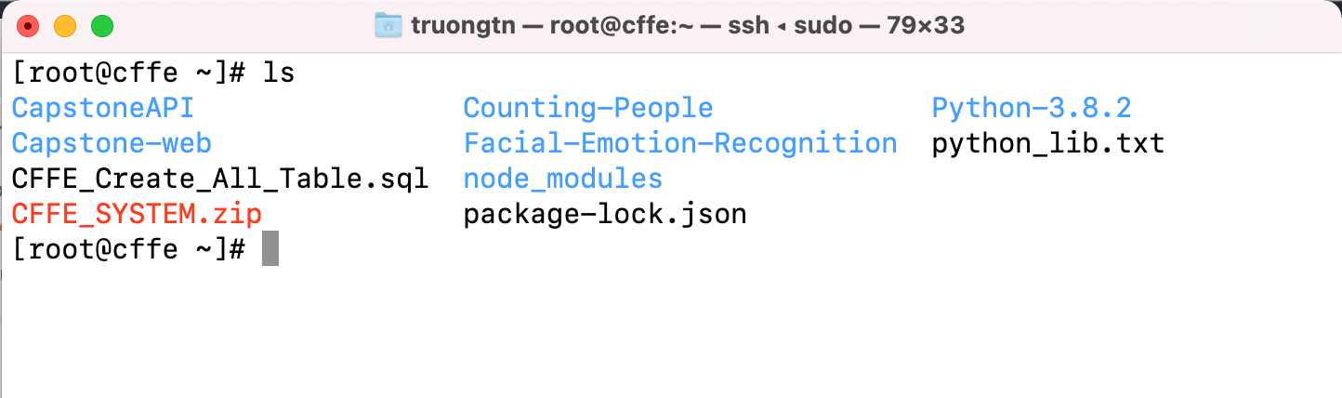

##### 3. Deploy the CFFE application.

1. Create the “CFFE_Database”:

1. Get the temporary password with this command: **grep 'temporary password' /var/log/mysqld.log**

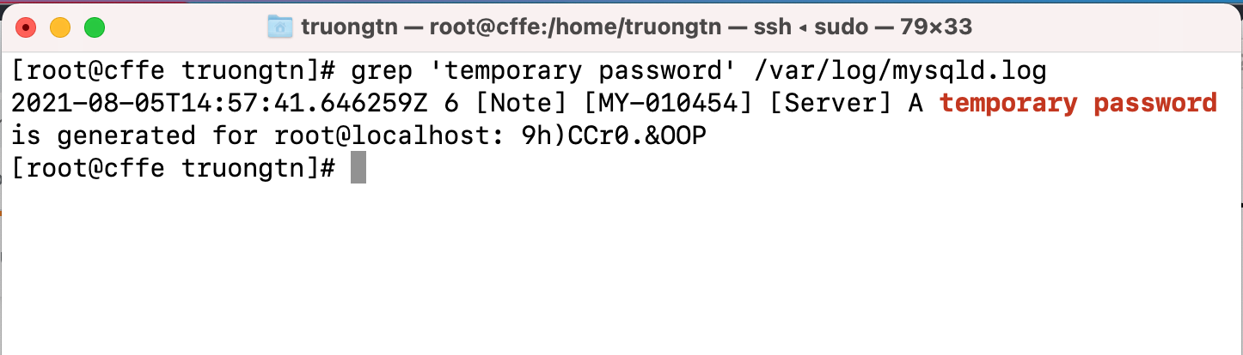

2. Change the password MySQL with this command: **mysql_secure_installation**

1. Input temporary password (1)

2. Input “y” to the change password (2)

3. Input new password and re-type password (3)

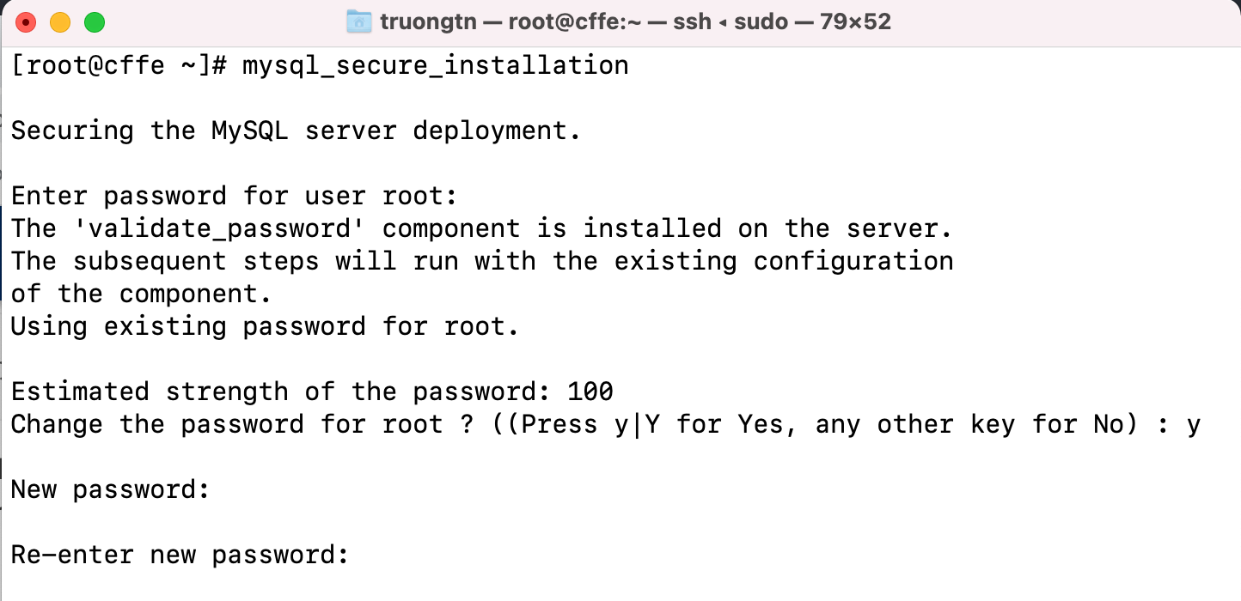

3

2

1

2. Create the “CFFE_Database” by running **mysql -u root -p < CFFE_Create_All_Table.sql** command with the password.



3. Check created “CFFE_Database”: run **mysql -u root -p** command with the password. Then, run **show databases;** command.

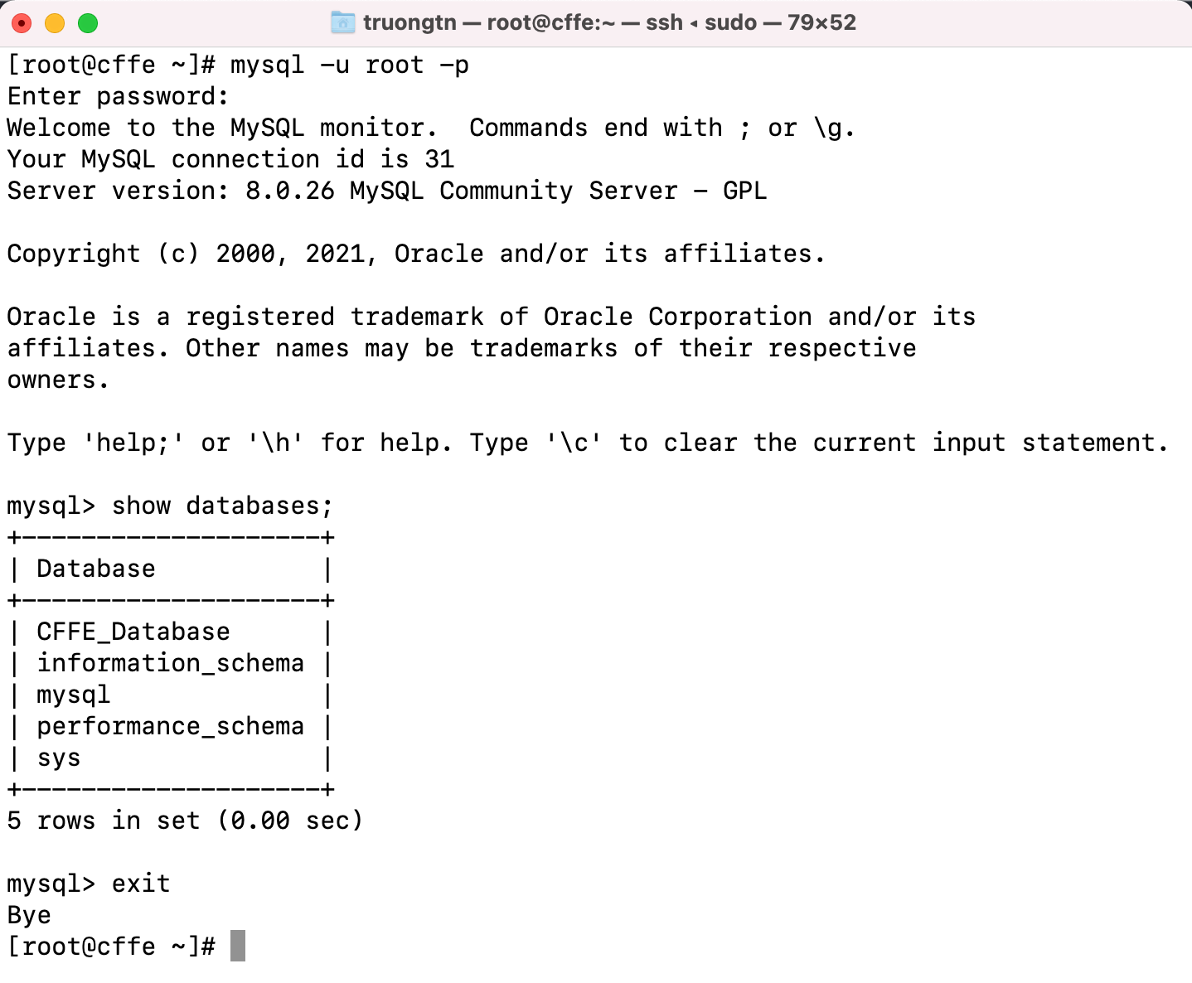

2. Edit config files.

1. Edit password MySQL in the file: **/root/CapstoneAPI/src/main/resources/SqlMapConfig.xml**

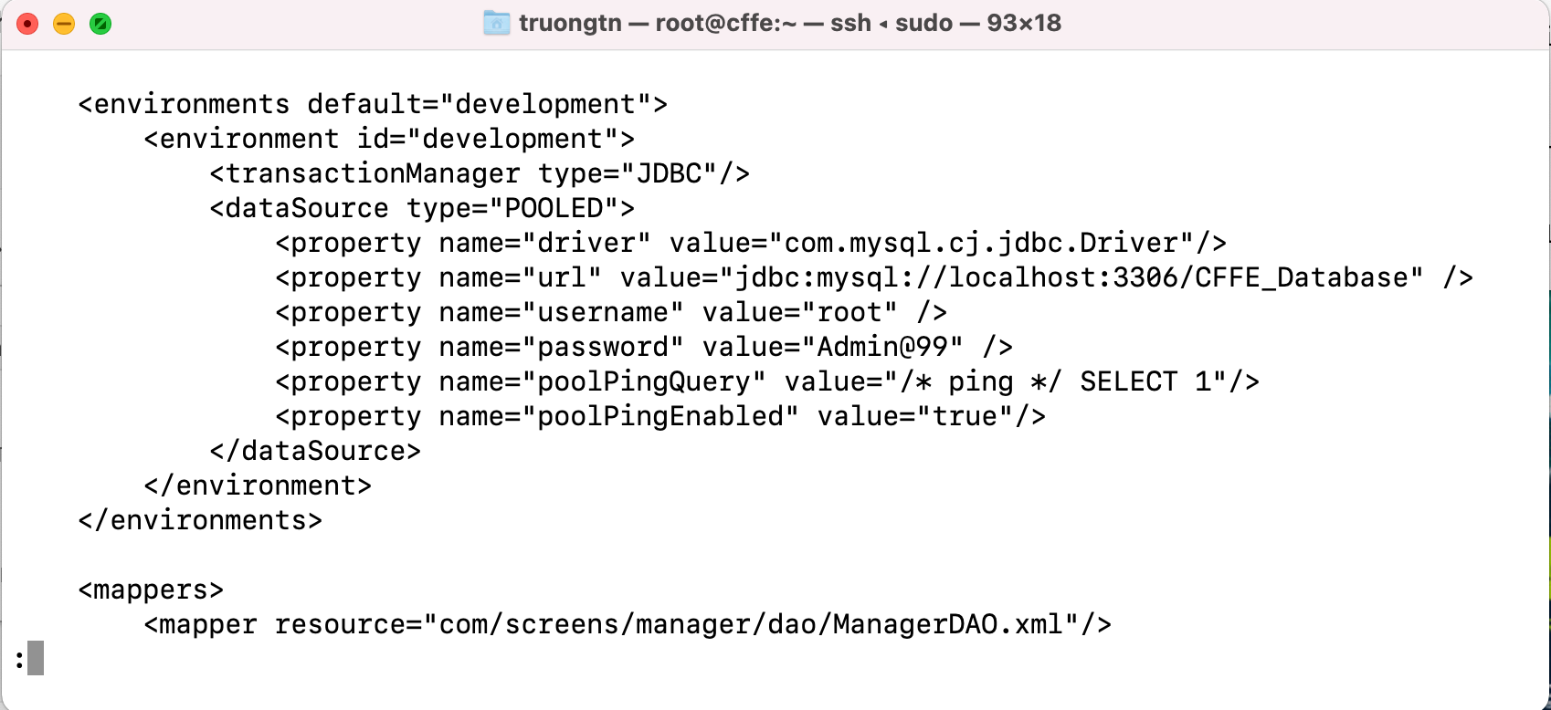

2. Get the public IP address with this command: **curl ifconfig.me**

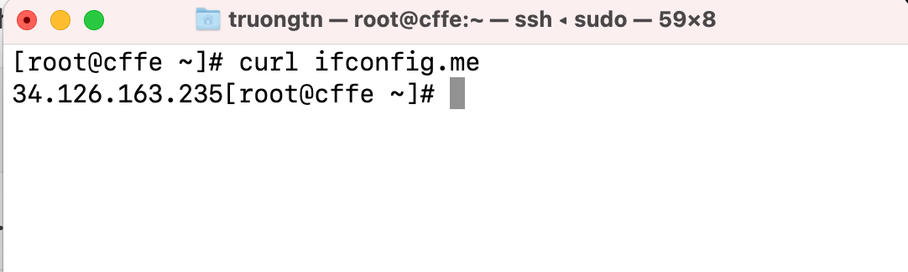

3. Change the public IP address in this file:

**Capstone-web/src/services/api.js**

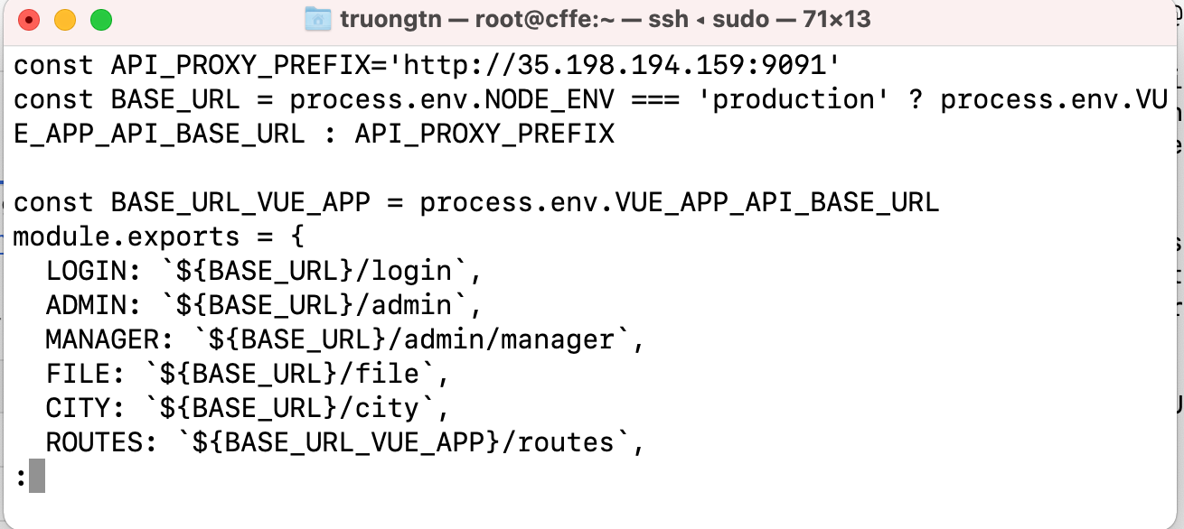

3. Deployment CFFE application.

1. Deploy the application with this command: **source ./DeploymentAPP.sh**



2. Access Backend API: Open browser and input URL:

**[public IP Address]:9091/swagger-ui/index.html**



3. Access CFFE web: Open browser and input URL:

**[public IP Address]:8080**



## 3. User Manual

### 3.1 Terms and definitions

N/A

### 3.2 System requirements

*See to* *section2.1*

### 3.3 Application Usage

#### 3.3.1. CFFE-Admin

**a. Overview**

Application used by admin when want to:

+ Login

+ Logout

+ View statistics

+ View video

+ Manage manager

+ Manage store

+ Manage camera

+ Manage product

+ Manage category

+ Manage own profile

Hình của Luận

**b. Login page:**

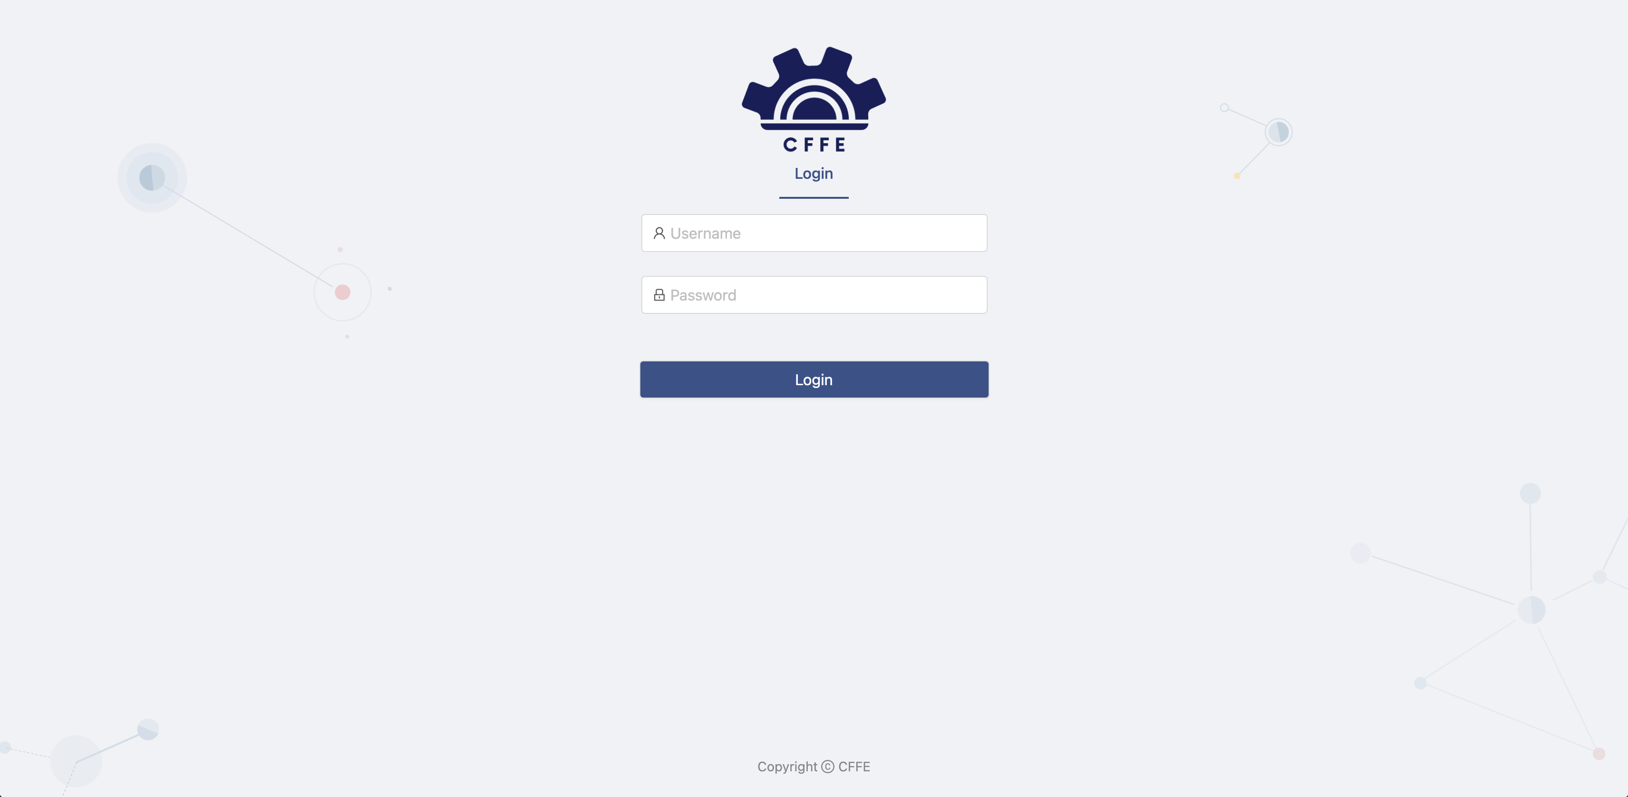

1

2

|  |  |
| --- | --- |
| **Step** | **Description** |
| 1 | Admin inputs the user. |
| 2 | Admin clicks “Login” button. |

**c. Dashboard page:**

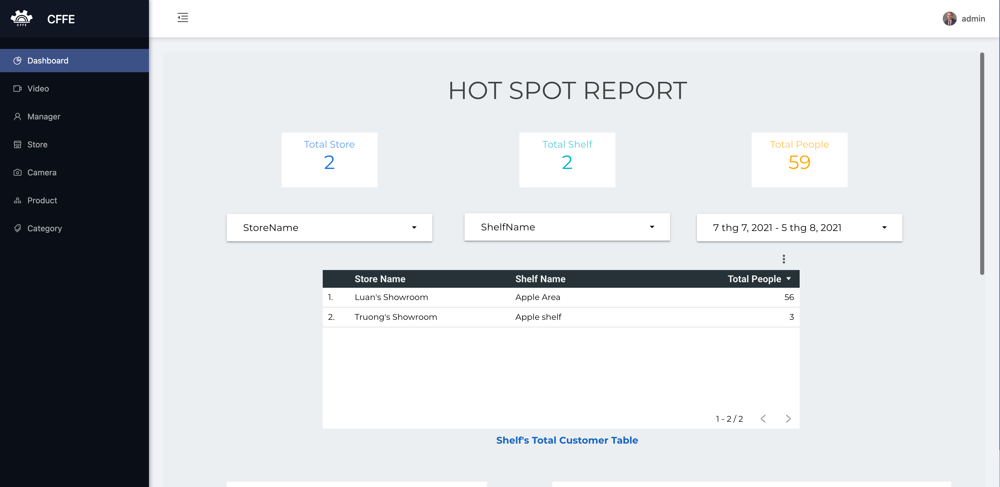

1

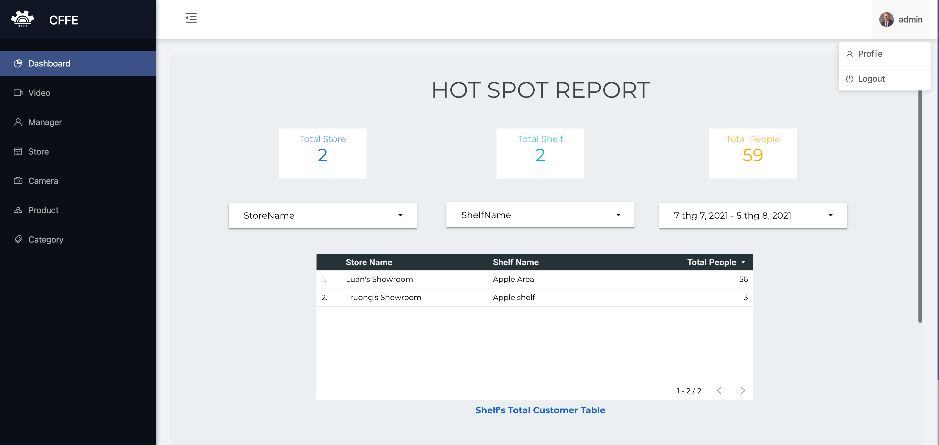

2

3

|  |  |
| --- | --- |
| **Step** | **Description** |
| 1 | Admin clicks own username to drop down items. |
| 2 | Admin clicks “Profile” item to view own profile. |
| 3 | Admin clicks “Logout” item to logout from the application. |

**d. Profile page.**

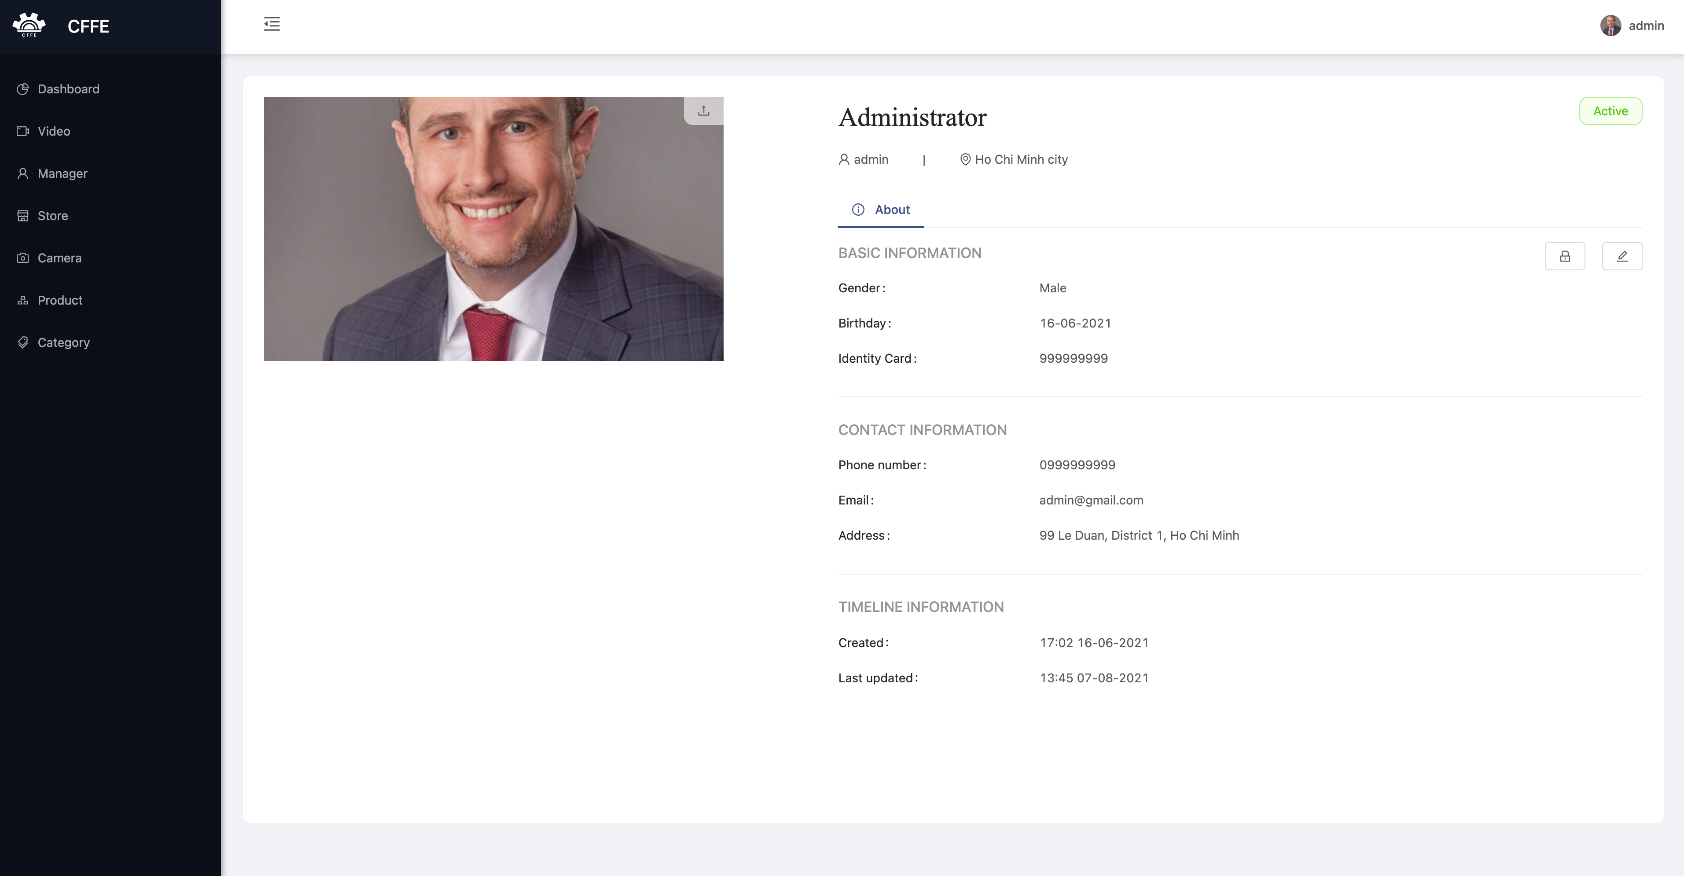

2

3

1

Figure 2. Profile page

|  |  |
| --- | --- |
| **Step** | **Description** |
| 1 | Admin clicks the icon to change own avatar. |
| 2 | Admin clicks the icon to change own password. |
| 3 | Admin clicks the icon to update own information. |

1. Change own avatar.

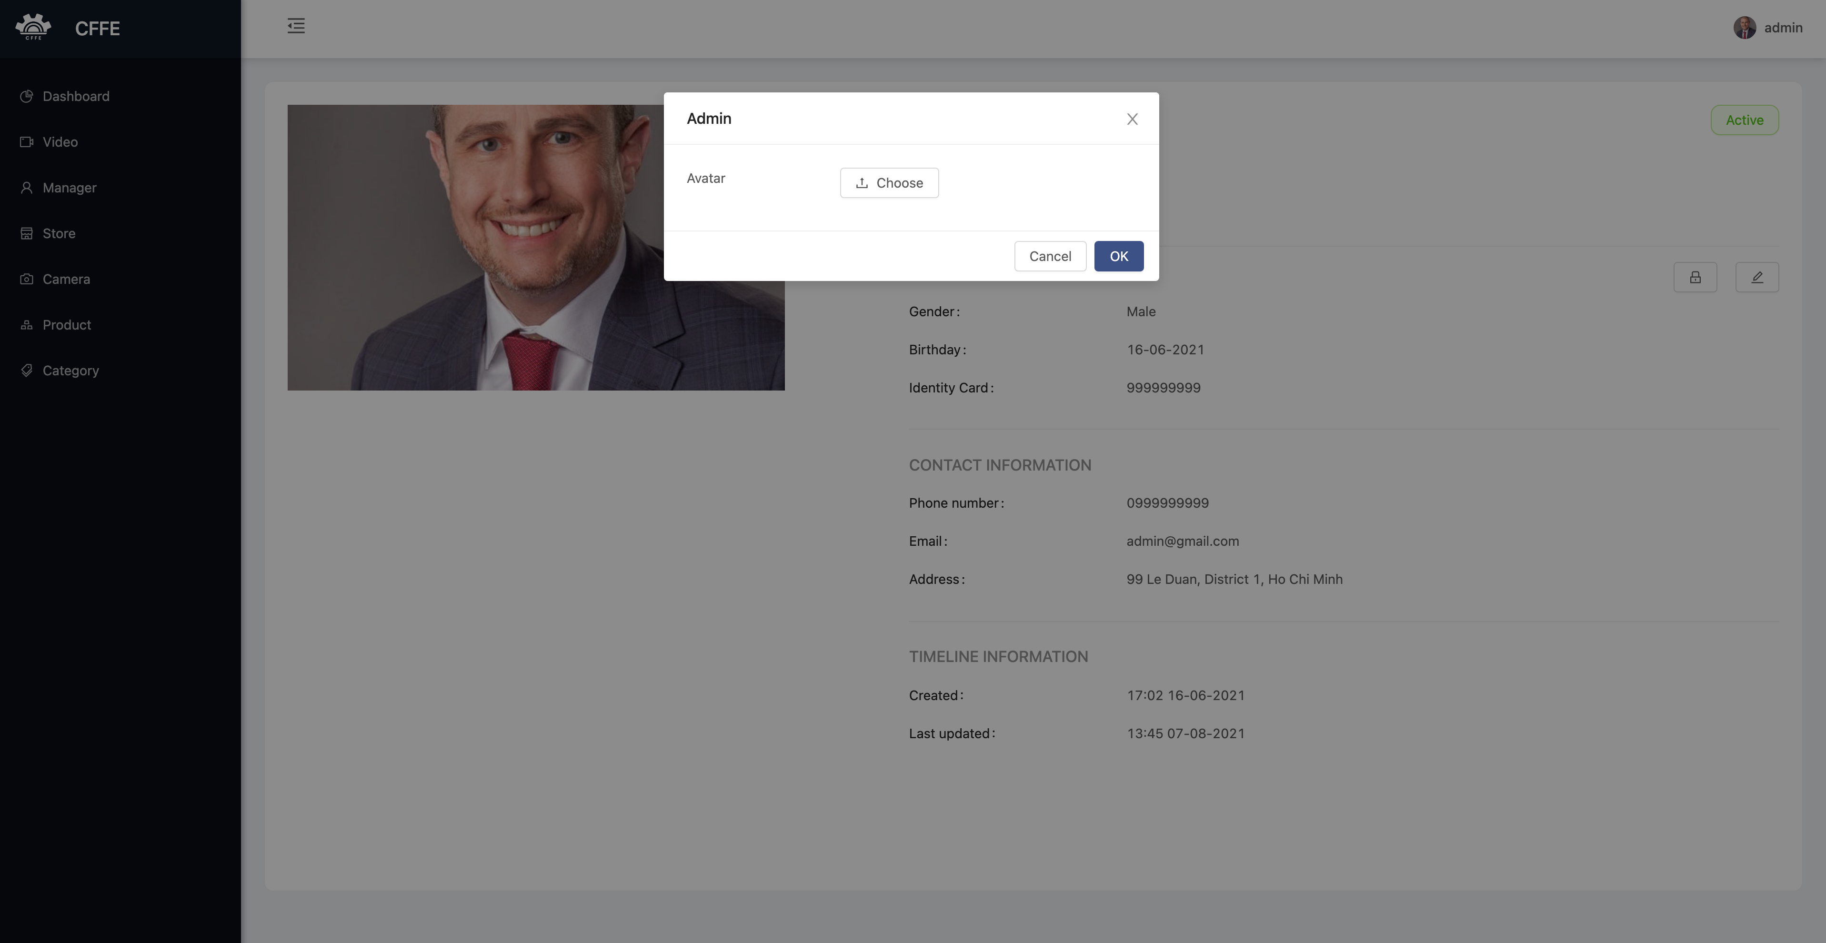

4

3

1

2

Figure 3. Profile page

|  |  |
| --- | --- |
| **Step** | **Description** |
| 1 | Admin clicks the icon to close the popup. |
| 2 | Admin clicks the button to choose an avatar from own computer. |
| 3 | Admin clicks “Cancel” button to cancel the command |
| 4 | Admin clicks “Ok” button to change own avatar. |

2. Change own password

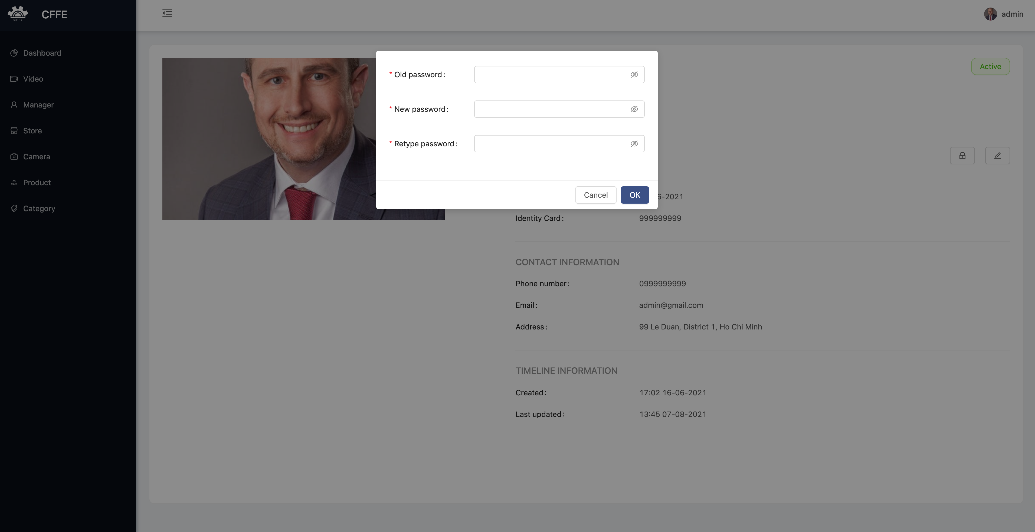

5

4

22

3

1

|  |  |
| --- | --- |
| **Step** | **Description** |
| 1 | Admin inputs own old password. |
| 2 | Admin inputs own new password. |
| 3 | Admin inputs own re-type password |
| 4 | Admin clicks “Cancel” button to cancel the command |
| 5 | Admin clicks “Ok” button to change own password. |

3. Update own information

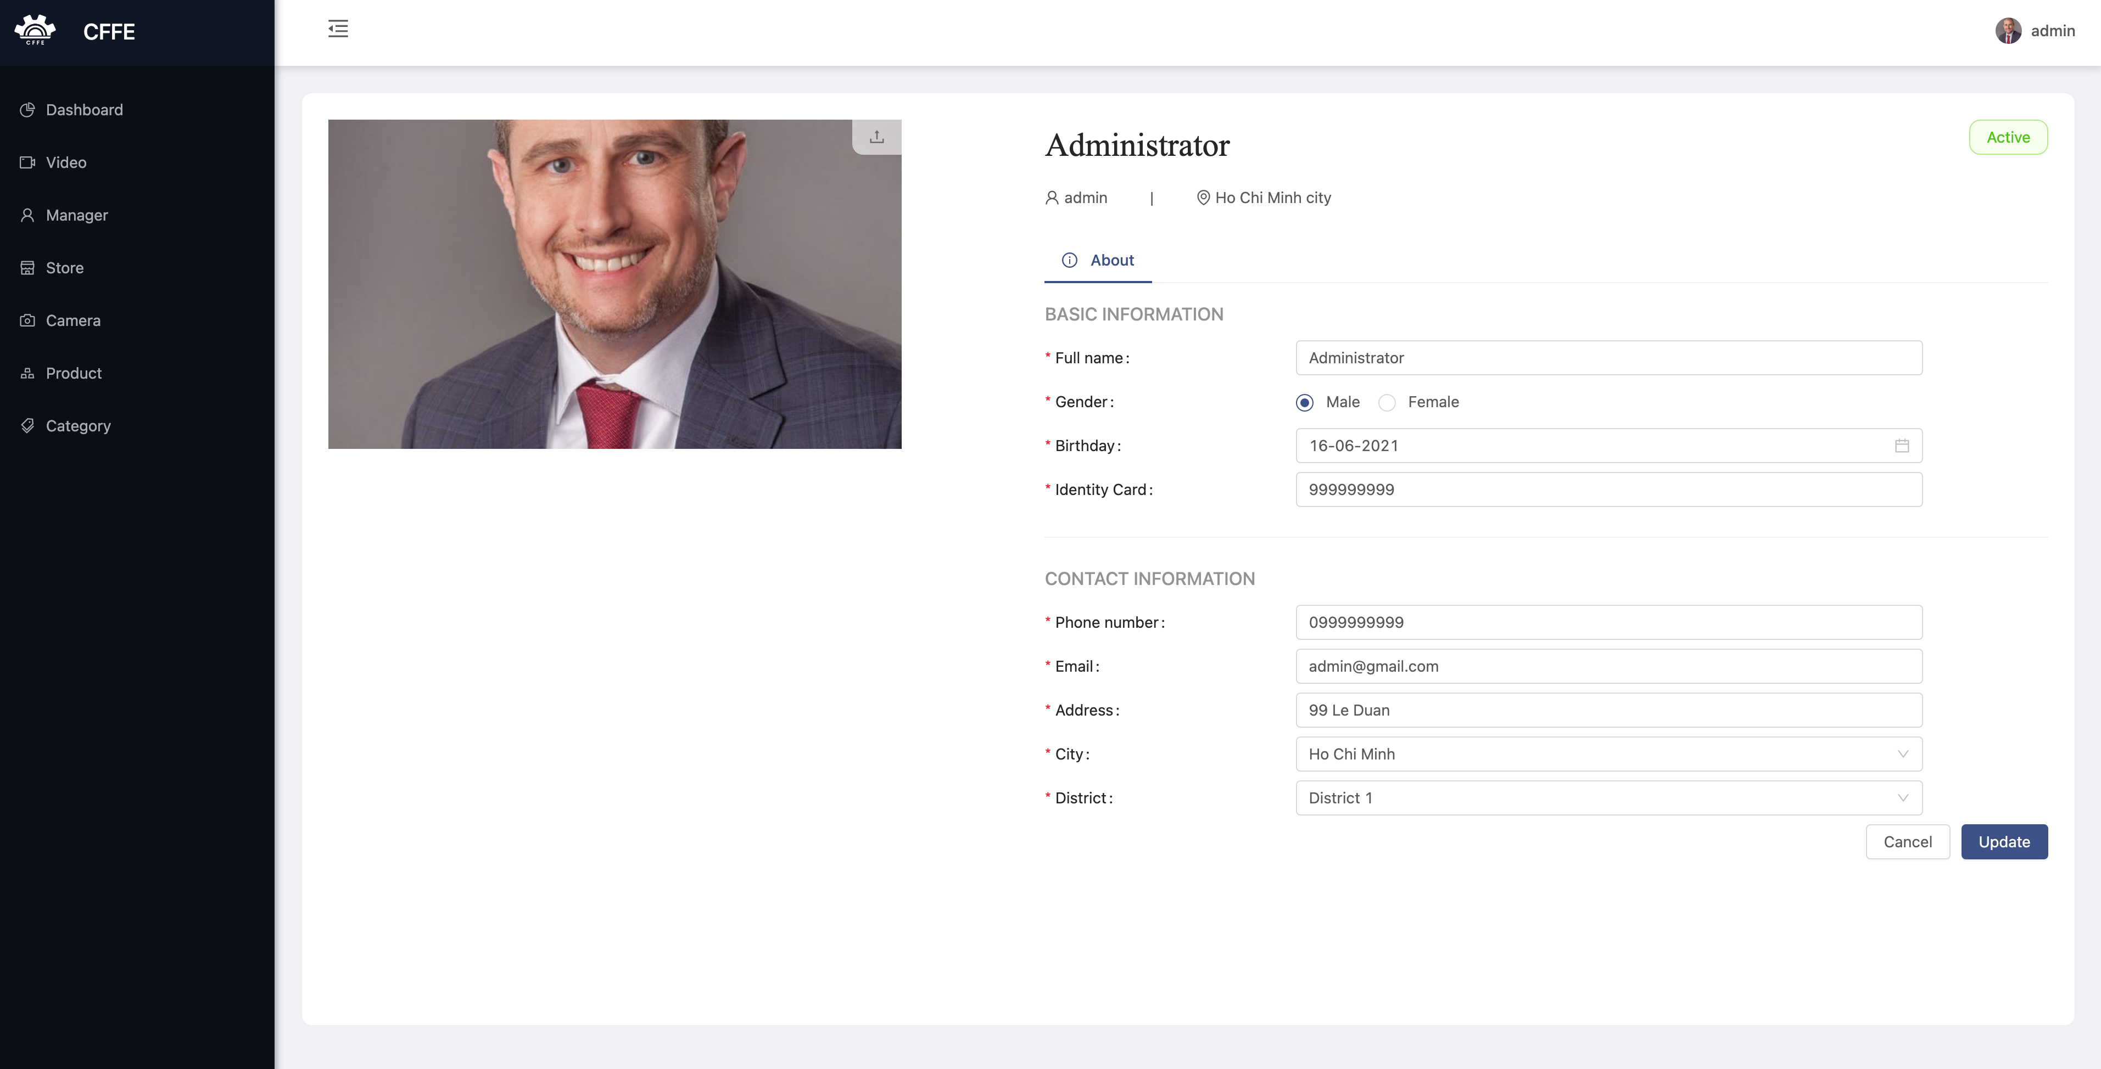

3

2

1

|  |  |
| --- | --- |
| **Step** | **Description** |
| 1 | Admin edits the necessary information. |
| 2 | Admin clicks “Cancel” button to cancel the command. |
| 3 | Admin clicks “Update” button to update own information |

**c. Video page**

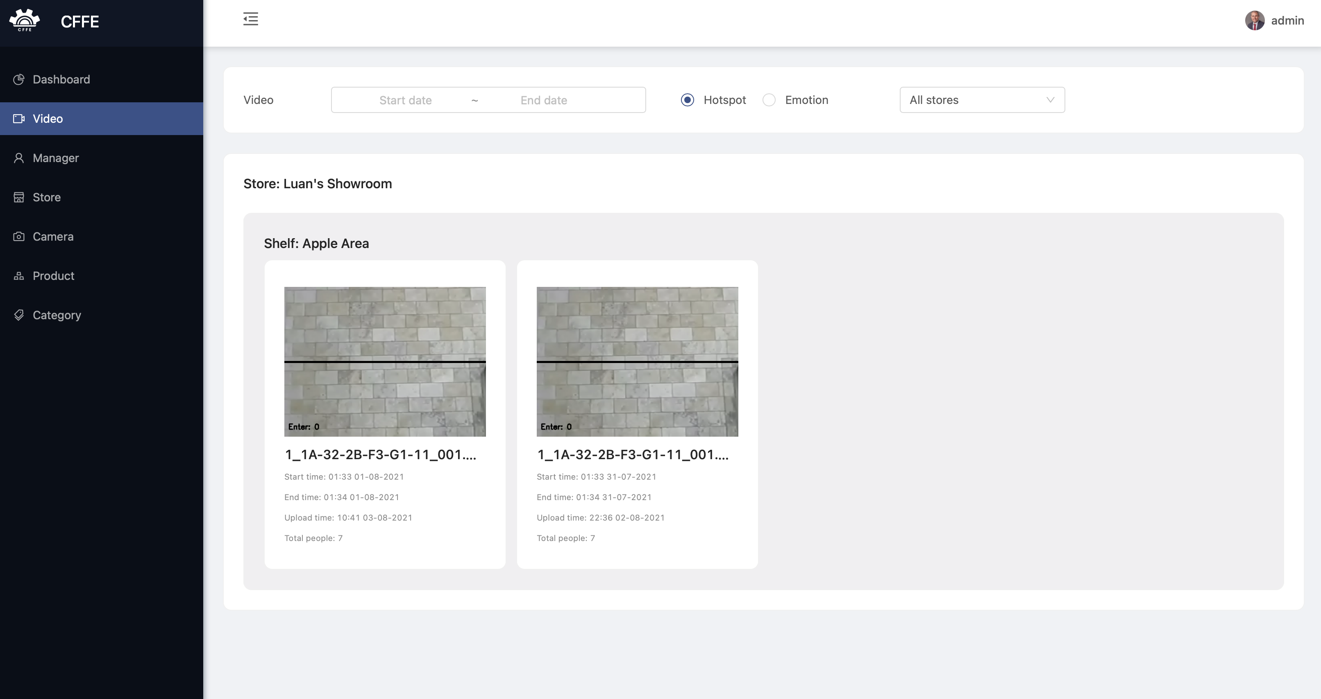

3

2

1

**d. Manager page**

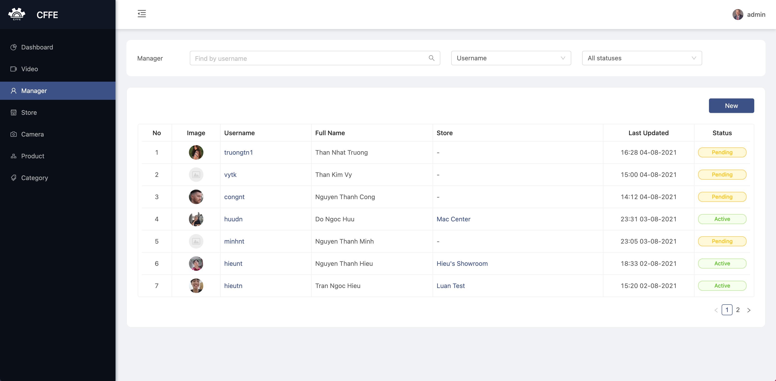

6

5

4

3

2

1

Figure 4. Manager page

Table 1. <User Guide> Manger page

|  |  |
| --- | --- |
| **Step** | **Description** |
| 1 | Admin inputs a search value. |
| 2 | Admin chooses a search field which is full name or username. |
| 3 | Admin chooses a filter which is all statuses, active, pending or inactive. |
| 4 | Admin clicks “New” button to create a new manager. |
| 5 | Admin clicks a username to view manager detail. |
| 6 | Admin clicks a store to view store detail |

1. Create a new manager

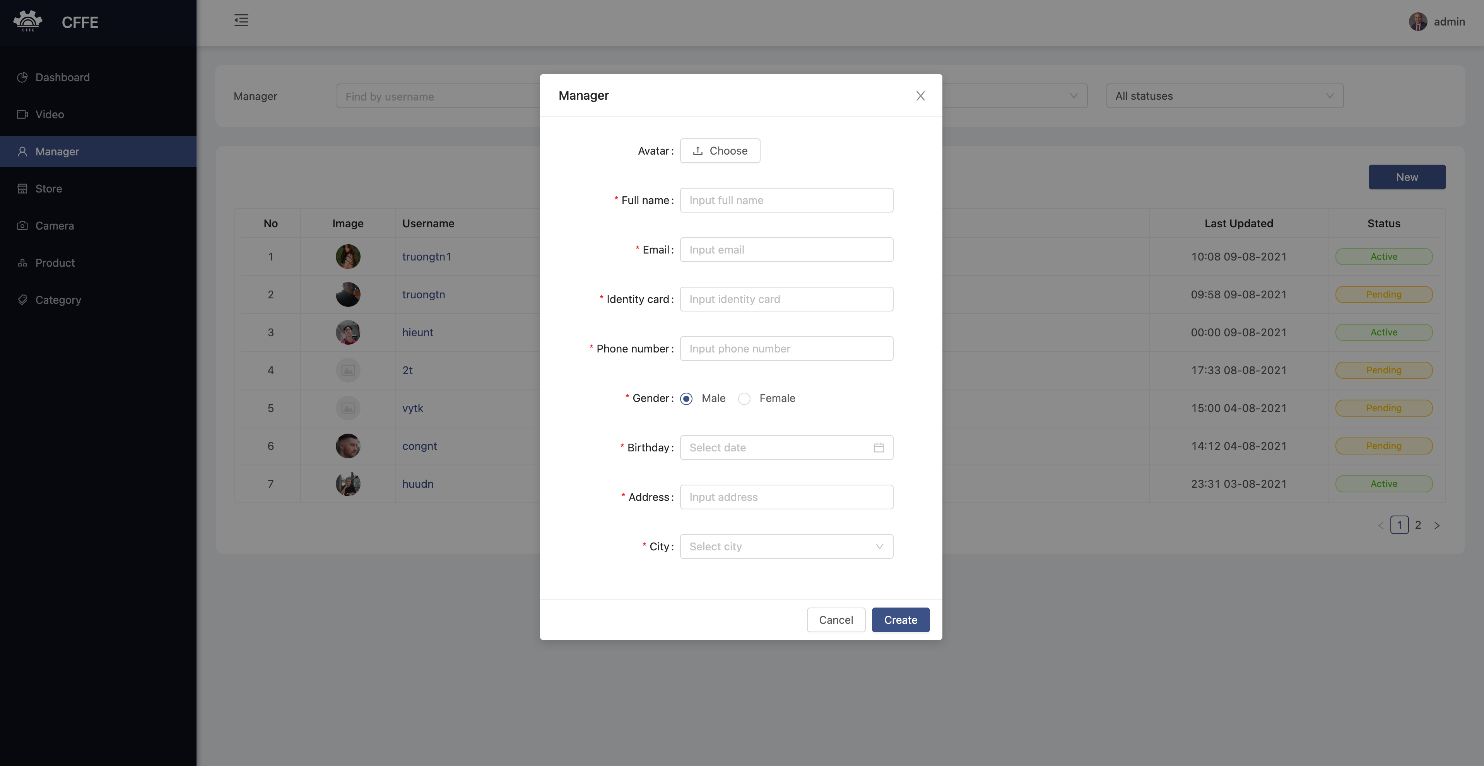

2

4

3

1

Figure 5. Create a new manager

|  |  |
| --- | --- |
| **Step** | **Description** |
| 1 | Admin clicks the close button to close the pop up. |
| 2 | Admin enters manager information. |
| 3 | Admin clicks “Cancel” button to cancel the command |
| 4 | Admin clicks “Ok” button to create a new manager. |

**d. Manager Detail Page**

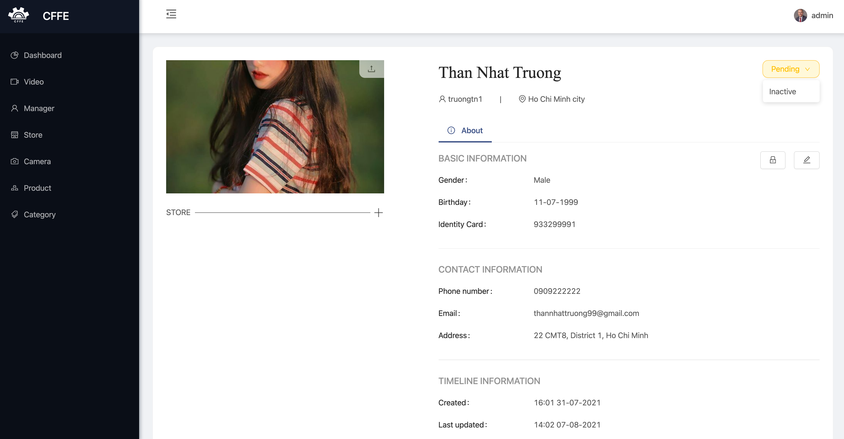

5

4

6

3

2

1

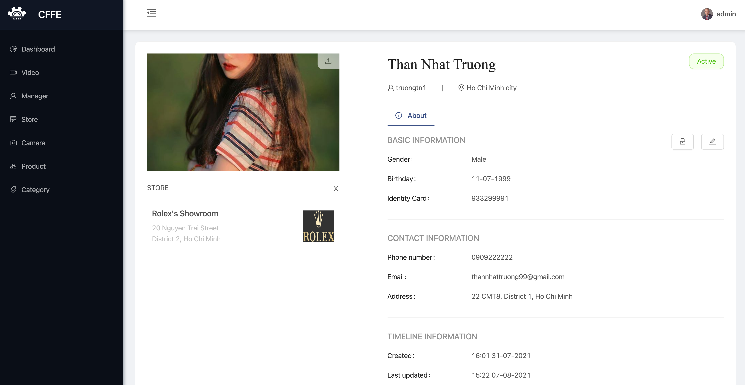

7

Figure x Manager detail page: The manager manages a store

|  |  |
| --- | --- |
| **Step** | **Description** |
| 1 | Admin clicks the icon to change the manager avatar. |
| 2 | Admin clicks “Pending” button to show “Inactive” button. |
| 3 | Admin clicks the button to delete the manager. |
| 4 | Admin clicks the icon to reset the manager’s password. |
| 5 | Admin clicks the icon to update the manager’s information. |
| 6 | Admin clicks the icon to add the store into the manager. |
| 7 | Admin clicks the icon to remove the store from the manager. |

1. Change the manager avatar.

1

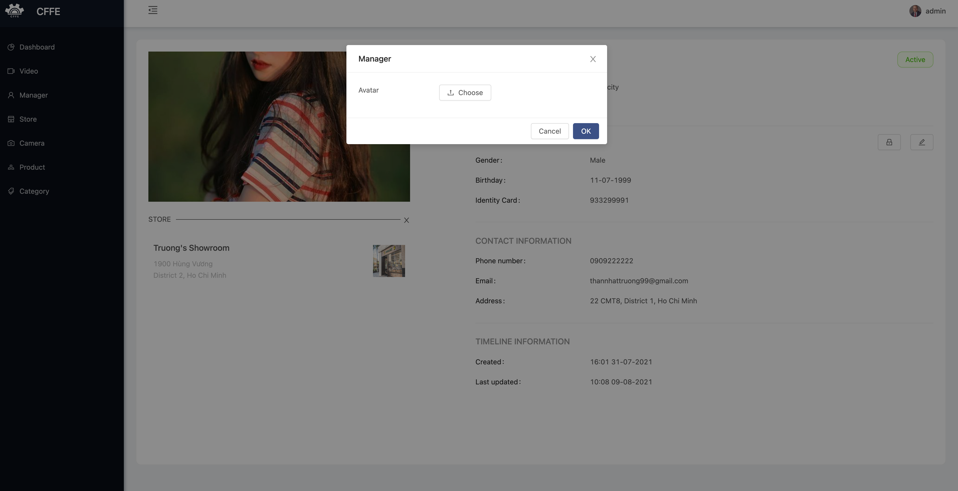

4

3

2

|  |  |
| --- | --- |
| **Step** | **Description** |
| 1 | Admin clicks the icon to close the popup. |
| 2 | Admin clicks the button to choose the manager avatar from own computer. |
| 3 | Admin clicks “Cancel” button to cancel the command. |
| 4 | Admin clicks “Ok” button to change the manager avatar. |

2. Delete the manager

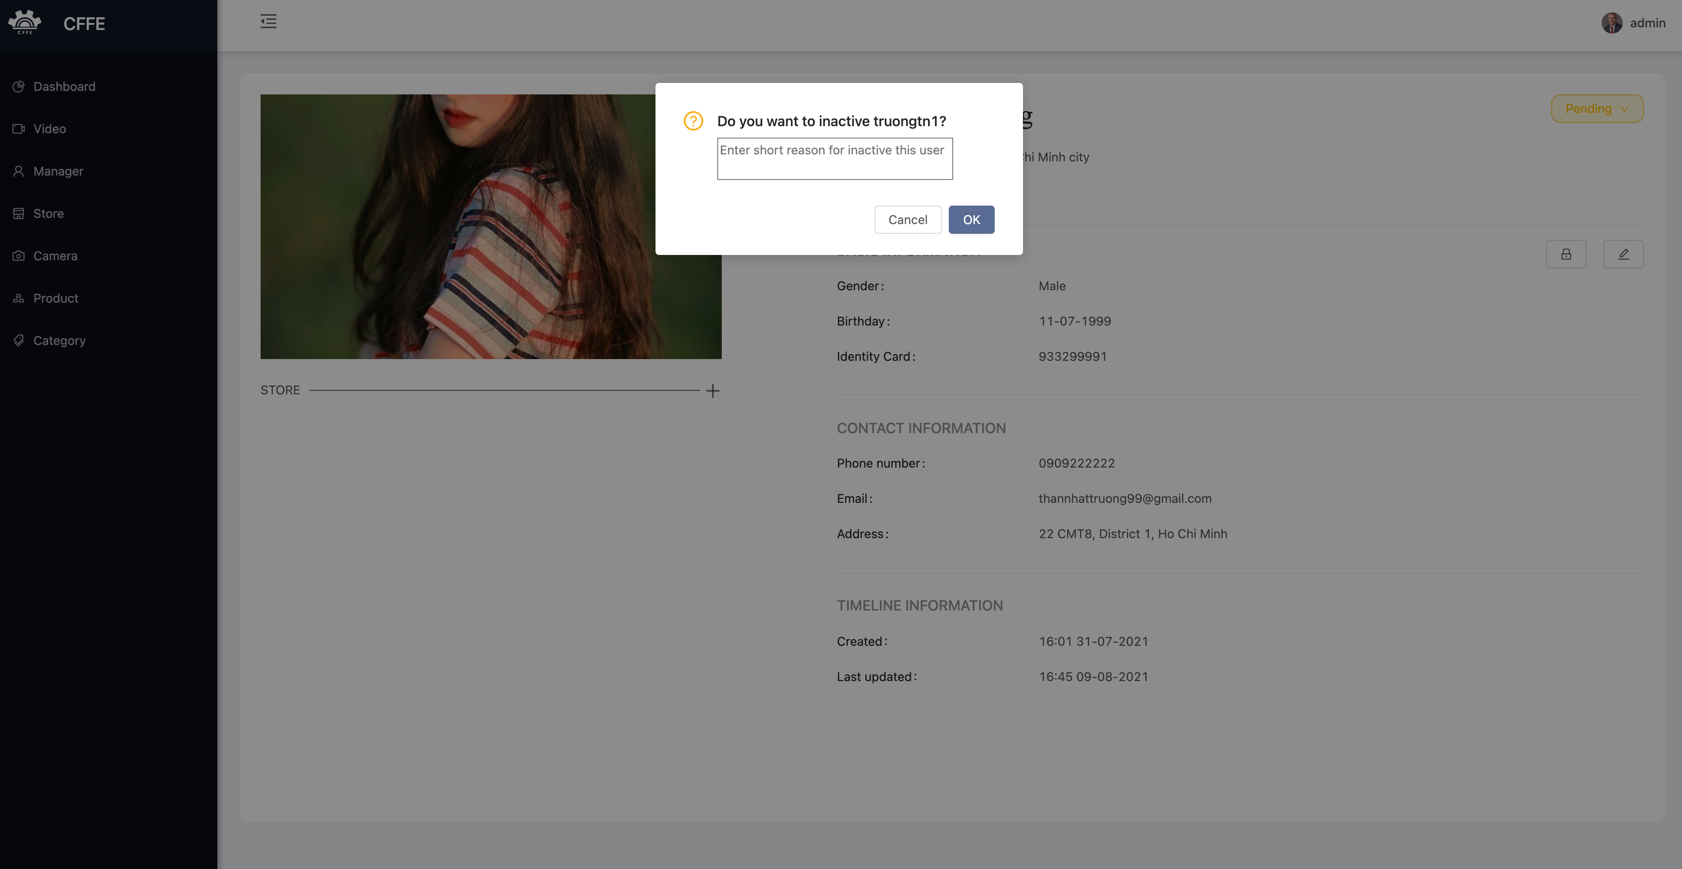

3

2

1

|  |  |
| --- | --- |
| **Step** | **Description** |
| 1 | Admin inputs an inactive reason. |
| 2 | Admin clicks “Cancel” button to cancel the command |
| 3 | Admin clicks “Ok” button to delete the manager. |

3. Reset the manager password.

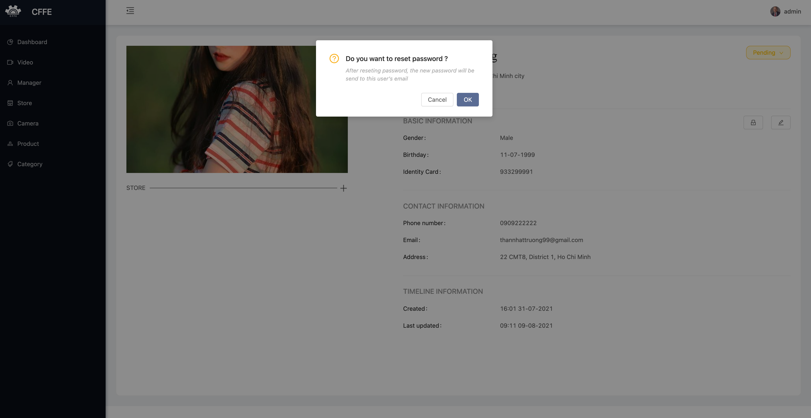

2

1

|  |  |
| --- | --- |
| **Step** | **Description** |
| 1 | Admin clicks “Cancel” button to cancel the command. |
| 2 | Admin clicks “Ok” button to reset the manager password. |

4. Update the manager information

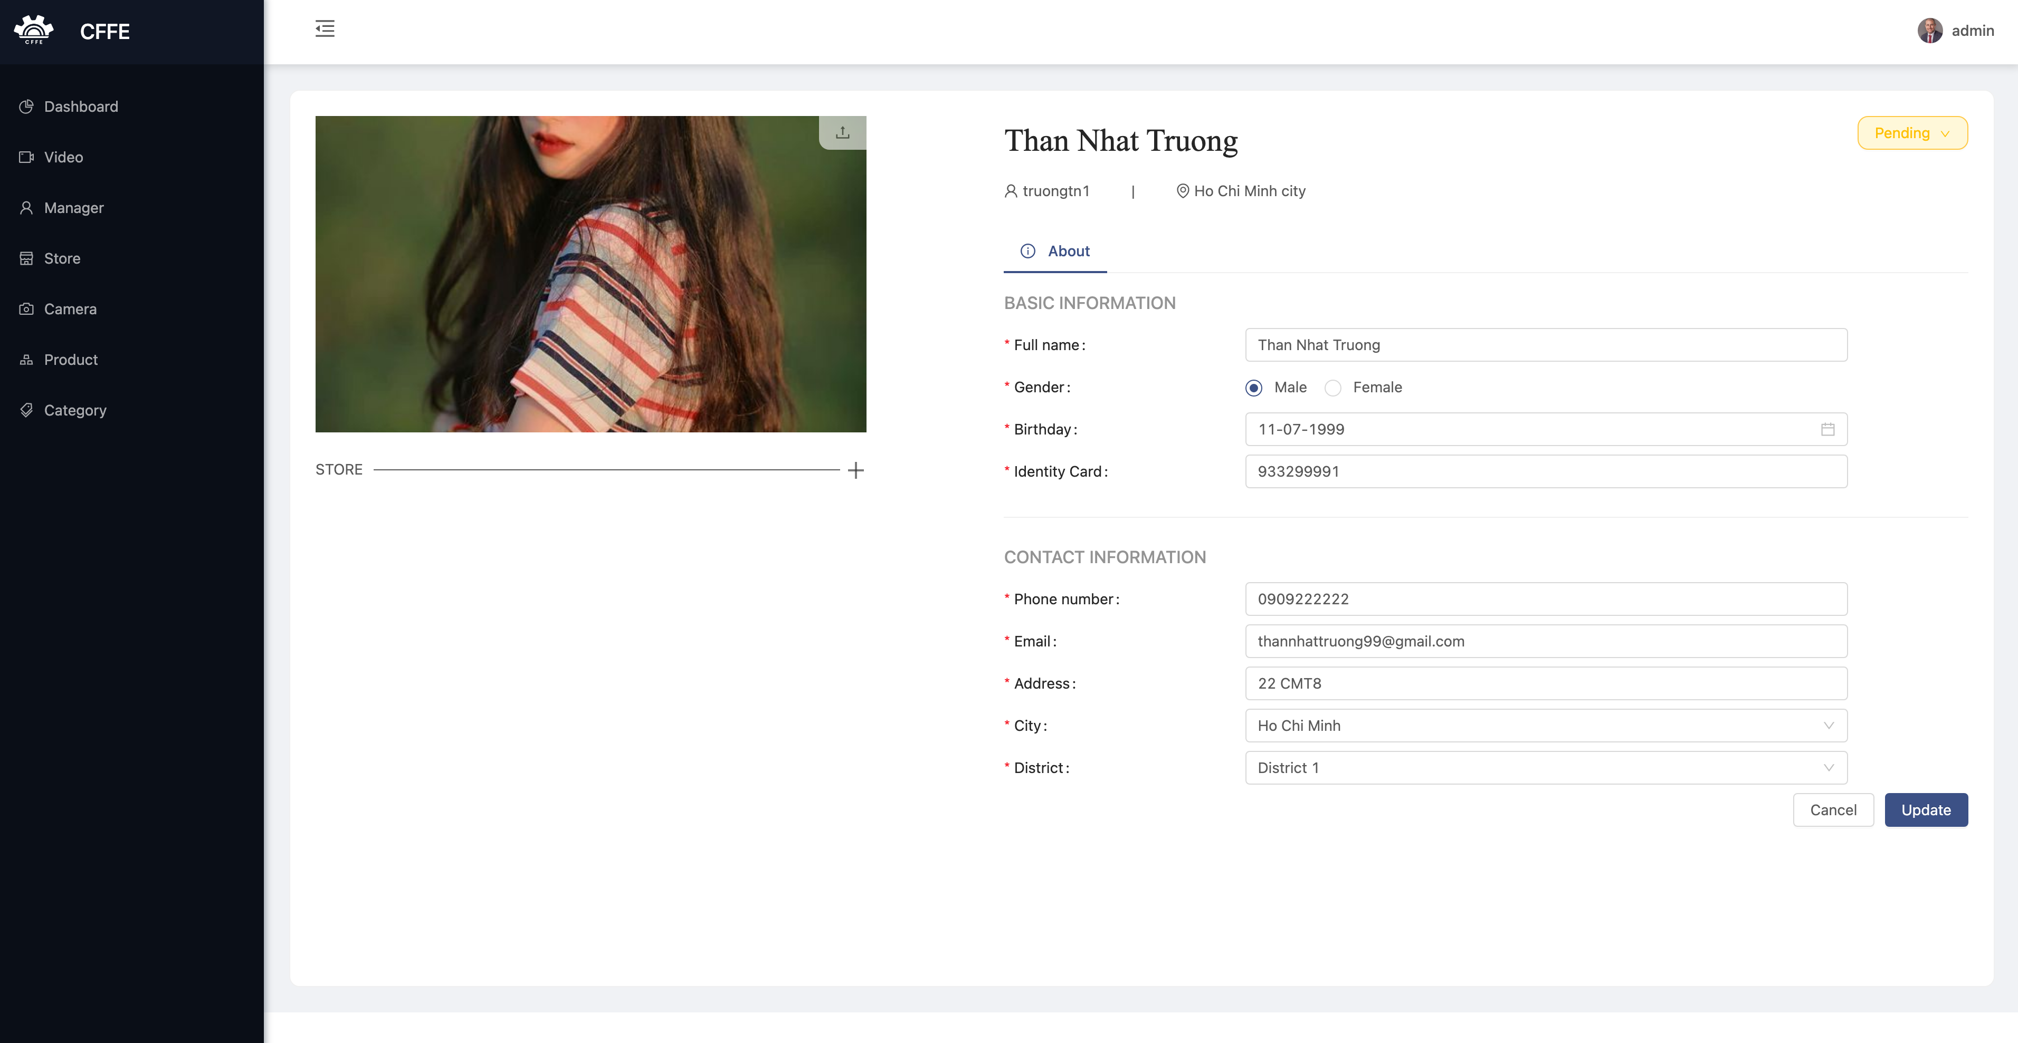

3

2

1

|  |  |
| --- | --- |
| **Step** | **Description** |
| 1 | Admin edits the necessary information of the manager. |
| 2 | Admin clicks “Cancel” button to cancel the command. |
| 3 | Admin clicks “Update” button to update the manager information. |

5.Add the store into the manager

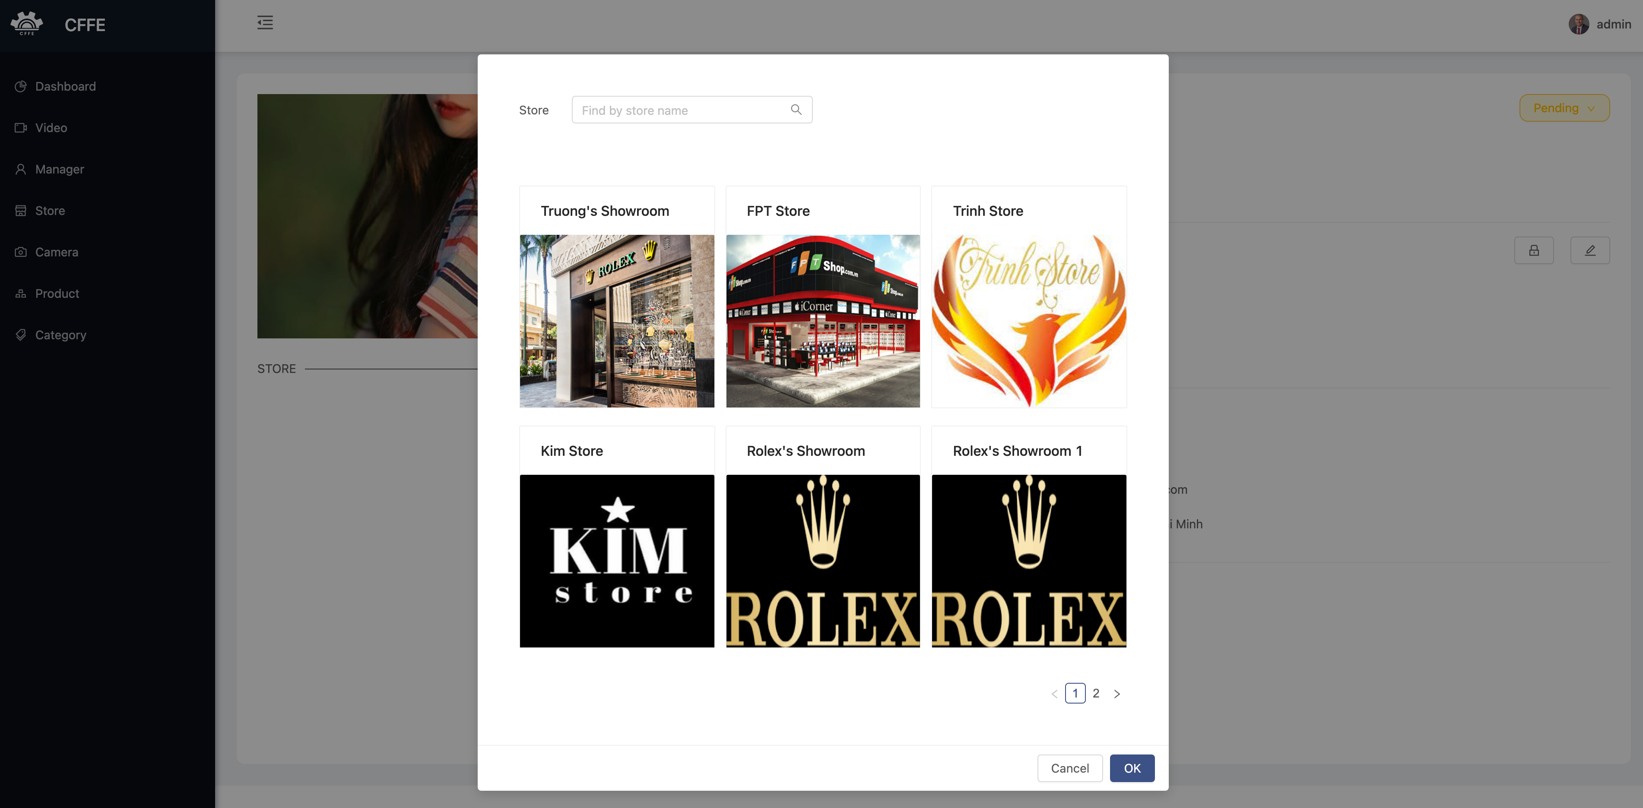

3

4

2

1

|  |  |
| --- | --- |
| **Step** | **Description** |
| 1 | Admin inputs a search value to find by store name. |
| 2 | Admin chooses a store in the available list. |
| 3 | Admin clicks “Cancel” button to cancel the command. |
| 4 | Admin clicks “Ok” button to add the store into the manager. |

6. Remove the store from the manager.

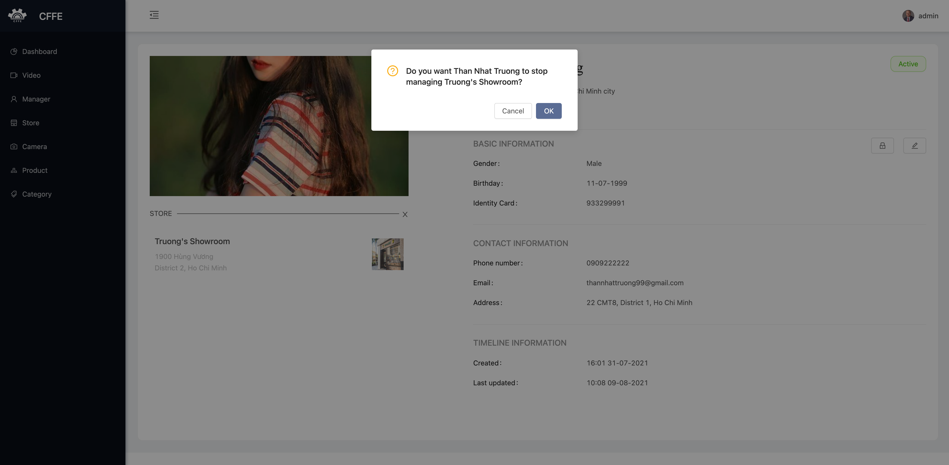

2

1

|  |  |
| --- | --- |
| **Step** | **Description** |
| 1 | Admin clicks “Cancel” button to cancel the command. |
| 2 | Admin clicks “Ok” button to remove the store from the manager. |

**e. Store page**

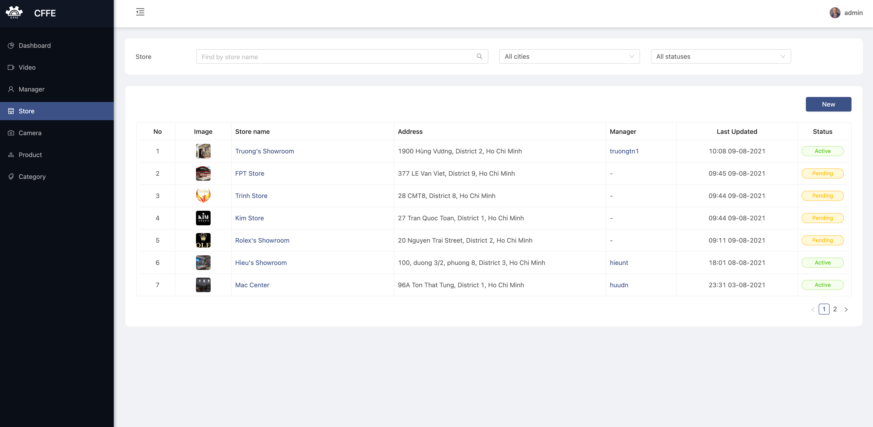

6

5

4

3

2

1

|  |  |
| --- | --- |
| **Step** | **Description** |
| 1 | Admin inputs a search value. |
| 2 | Admin chooses a filter which is all cities or a city in the dropdown list. |
| 3 | Admin chooses a filter which is all statuses, active, pending or inactive. |
| 4 | Admin clicks “New” button to create a new manager. |
| 5 | Admin clicks a username to view manager detail. |
| 6 | Admin clicks a store to view store detail. |

1. Create a new store

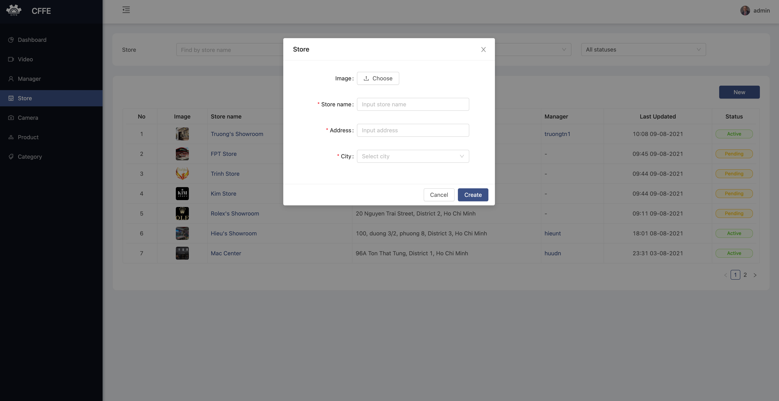

4

3

2

1

|  |  |
| --- | --- |
| **Step** | **Description** |
| 1 | Admin clicks the close button to close the pop up. |
| 2 | Admin enters store information. |
| 3 | Admin clicks “Cancel” button to cancel the command |
| 4 | Admin clicks “Ok” button to create a new store. |

**f. Store detail page**

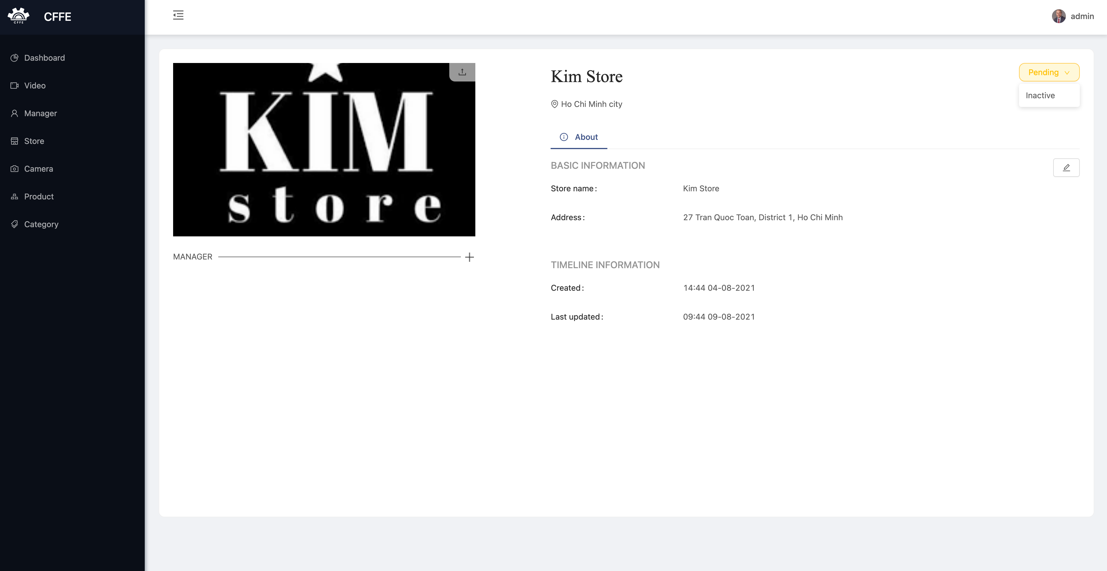

6

4

3

2

56

1

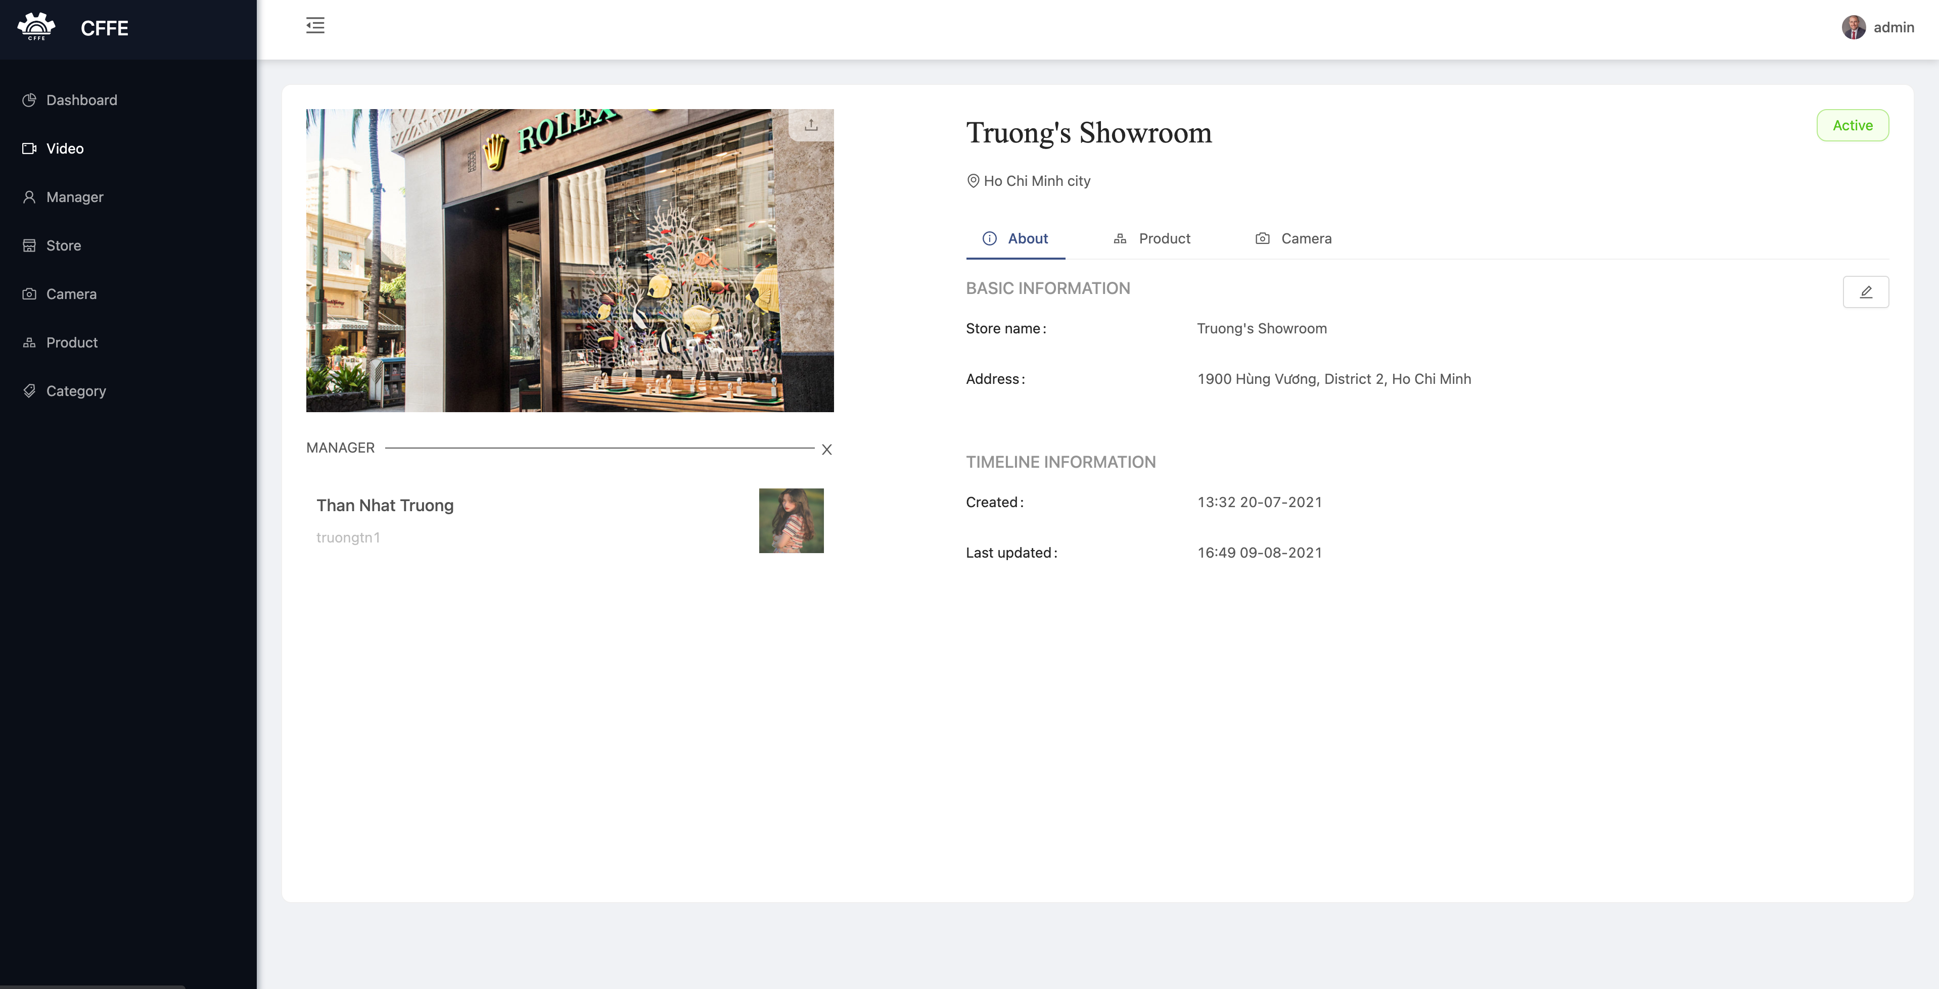

9

8

7

|  |  |
| --- | --- |
| **Step** | **Description** |
| 1 | Admin clicks the icon to change the store avatar. |
| 2 | Admin clicks “Pending” button to show “Inactive” button. |
| 3 | Admin clicks the button to delete the store |
| 4 | Admin clicks the icon to view the store information. |
| 5 | Admin clicks the icon to update the store information. |
| 6 | Admin clicks the icon to add a manager into the store. |
| 7 | Admin clicks the icon to view product list of the store. |
| 8 | Admin clicks the icon to view camera list of the store. |
| 9 | Admin clicks the icon to remove the manager from the store. |

1. Change the store avatar

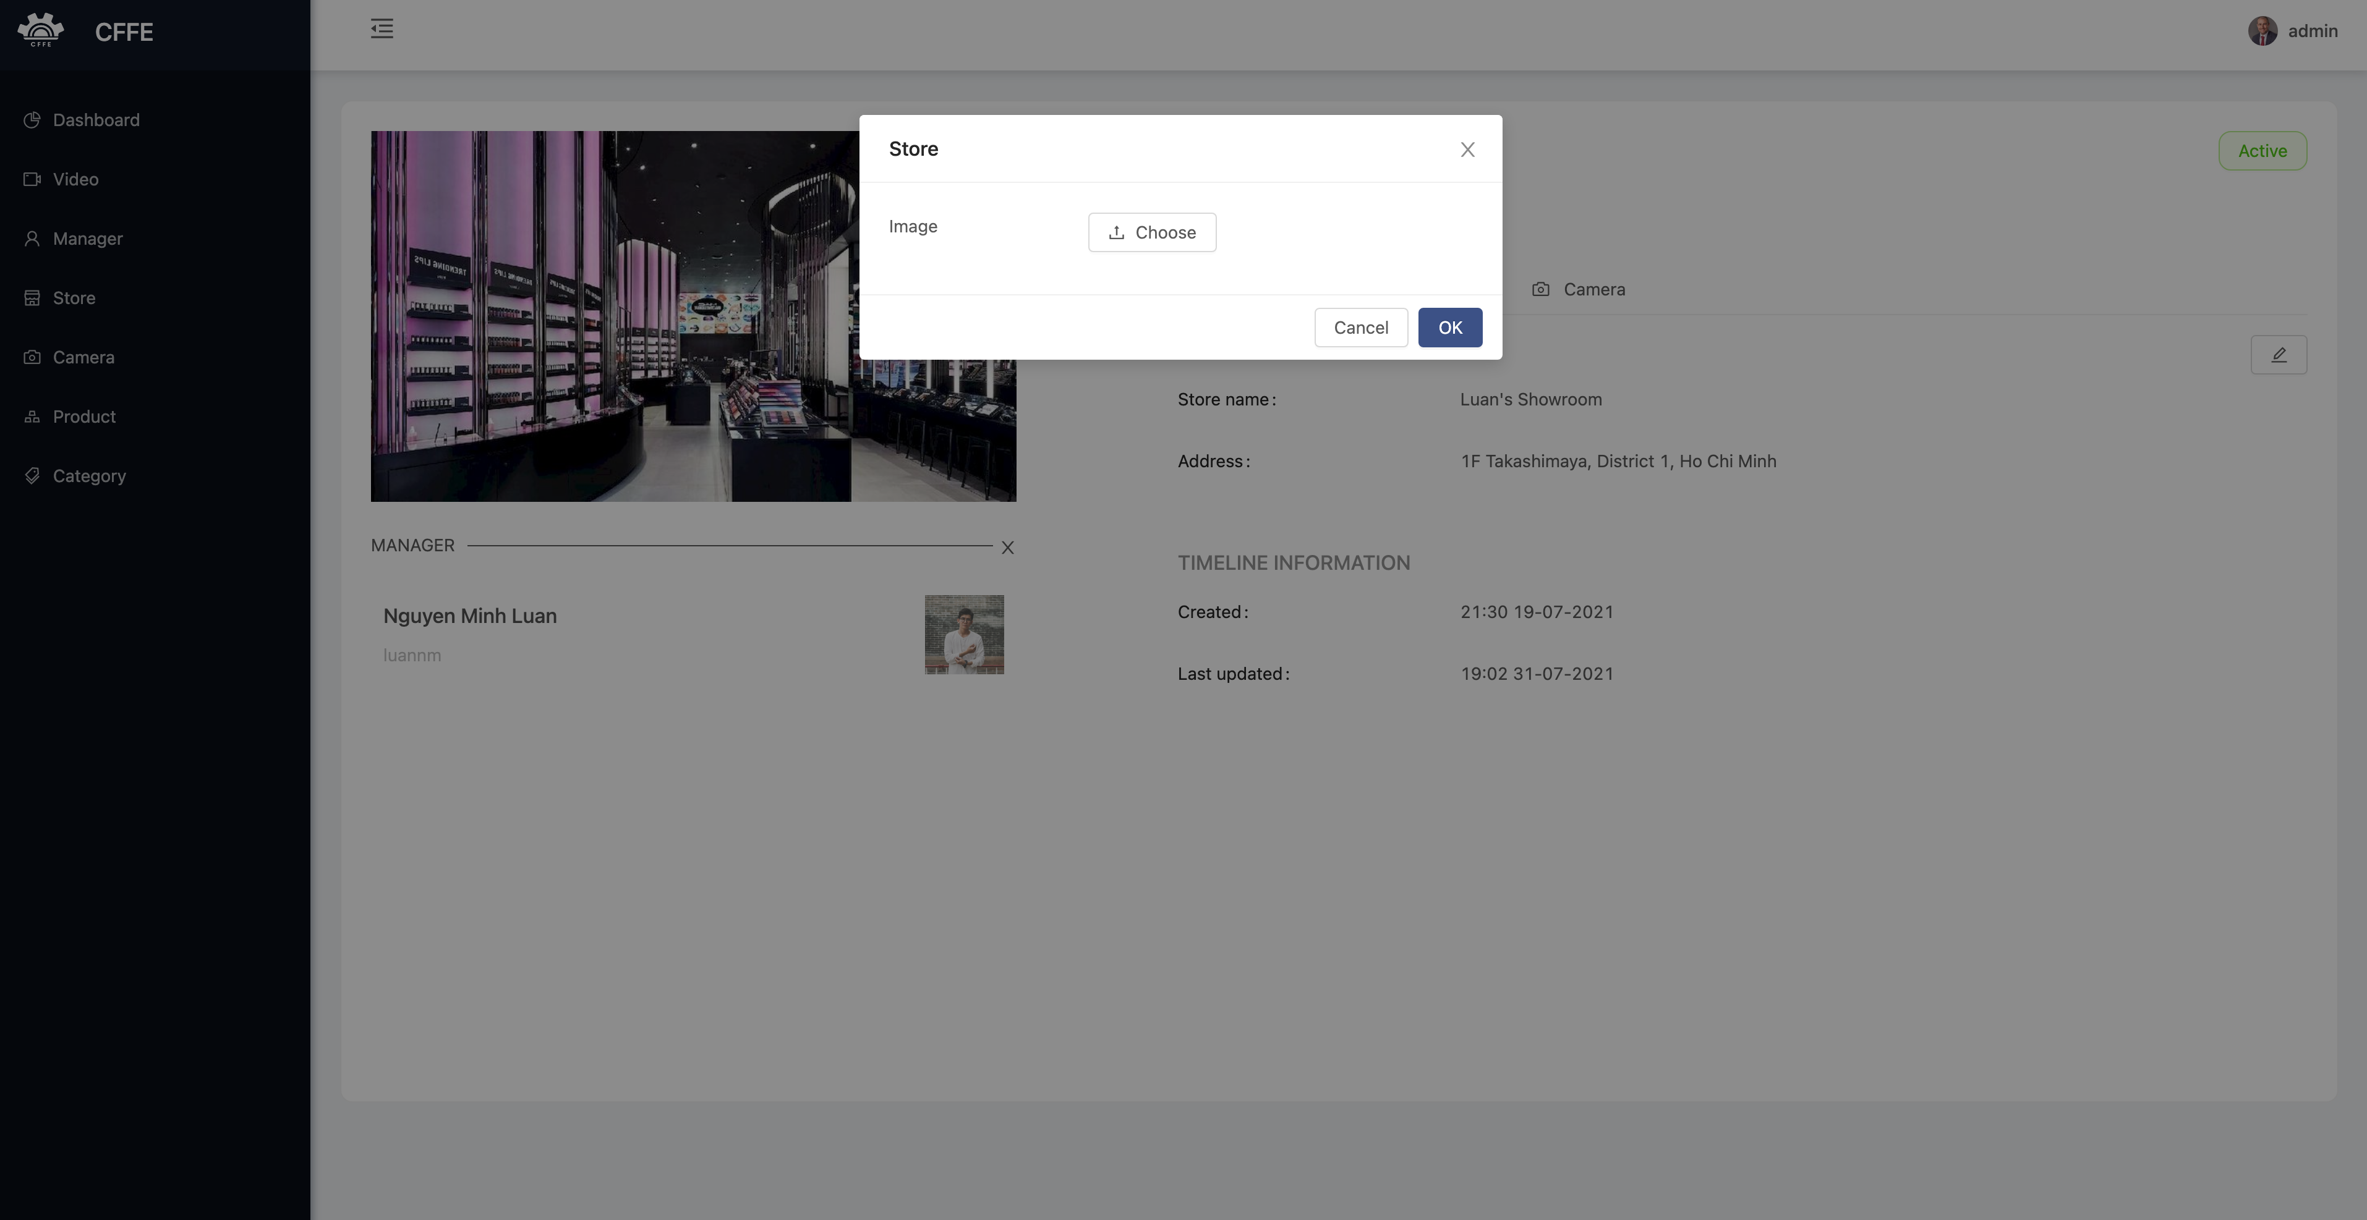

4

3

2

1

|  |  |
| --- | --- |
| **Step** | **Description** |
| 1 | Admin clicks the icon to close the popup. |
| 2 | Admin clicks the button to choose the store avatar from own computer. |
| 3 | Admin clicks “Cancel” button to cancel the command |
| 4 | Admin clicks “Ok” button to change the store avatar. |

2. Delete the store.

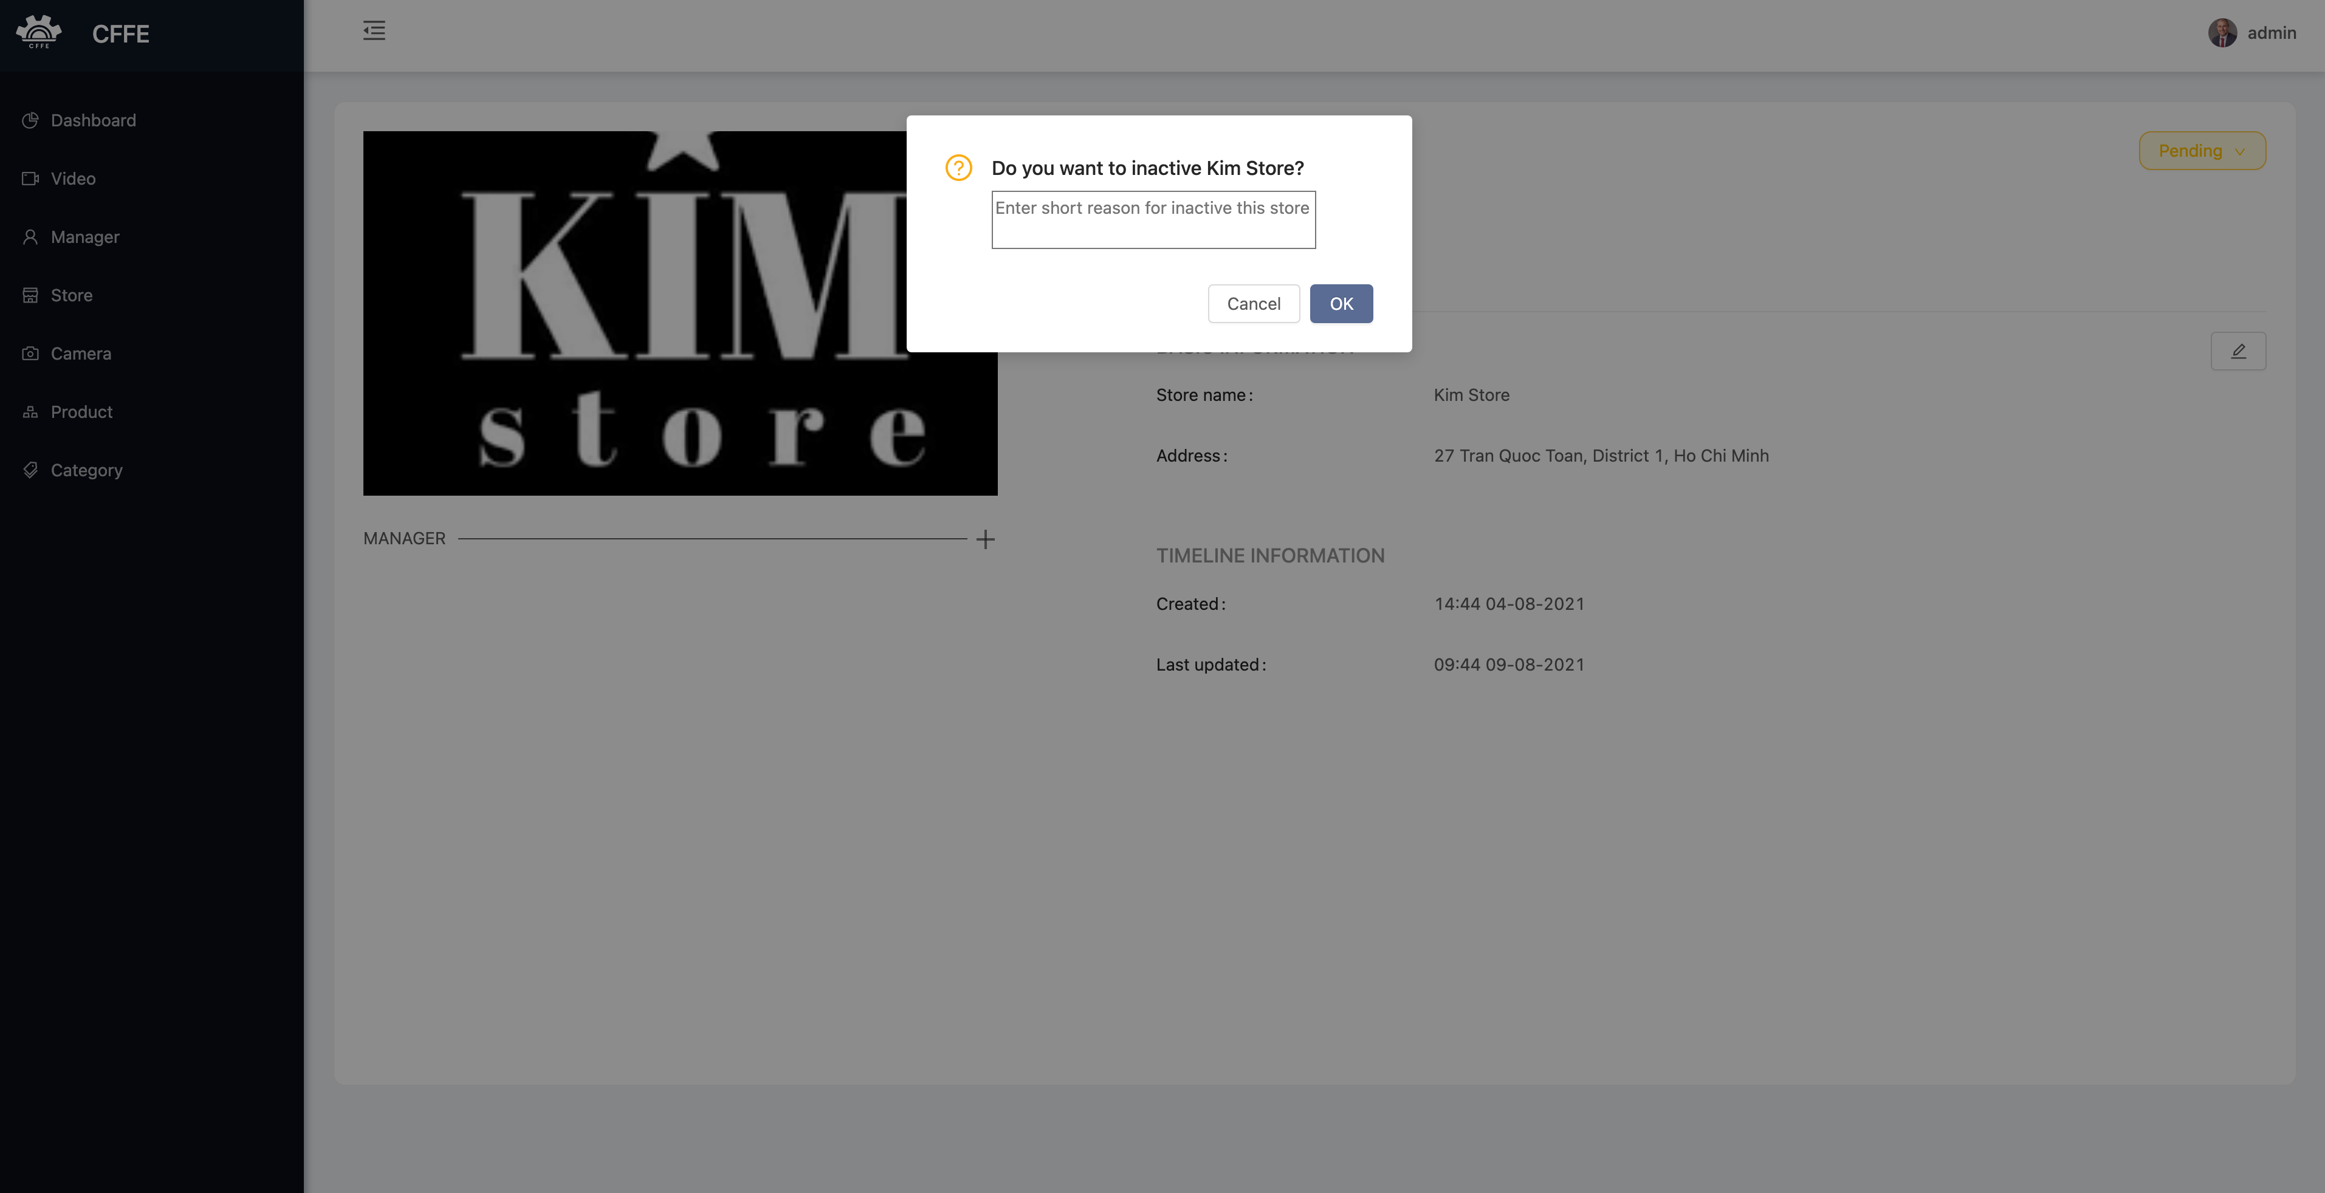

3

2

1

|  |  |
| --- | --- |
| **Step** | **Description** |
| 1 | Admin inputs an inactive reason. |
| 2 | Admin clicks “Cancel” button to cancel the command |
| 3 | Admin clicks “Ok” button to delete the store. |

3. Update the store information.

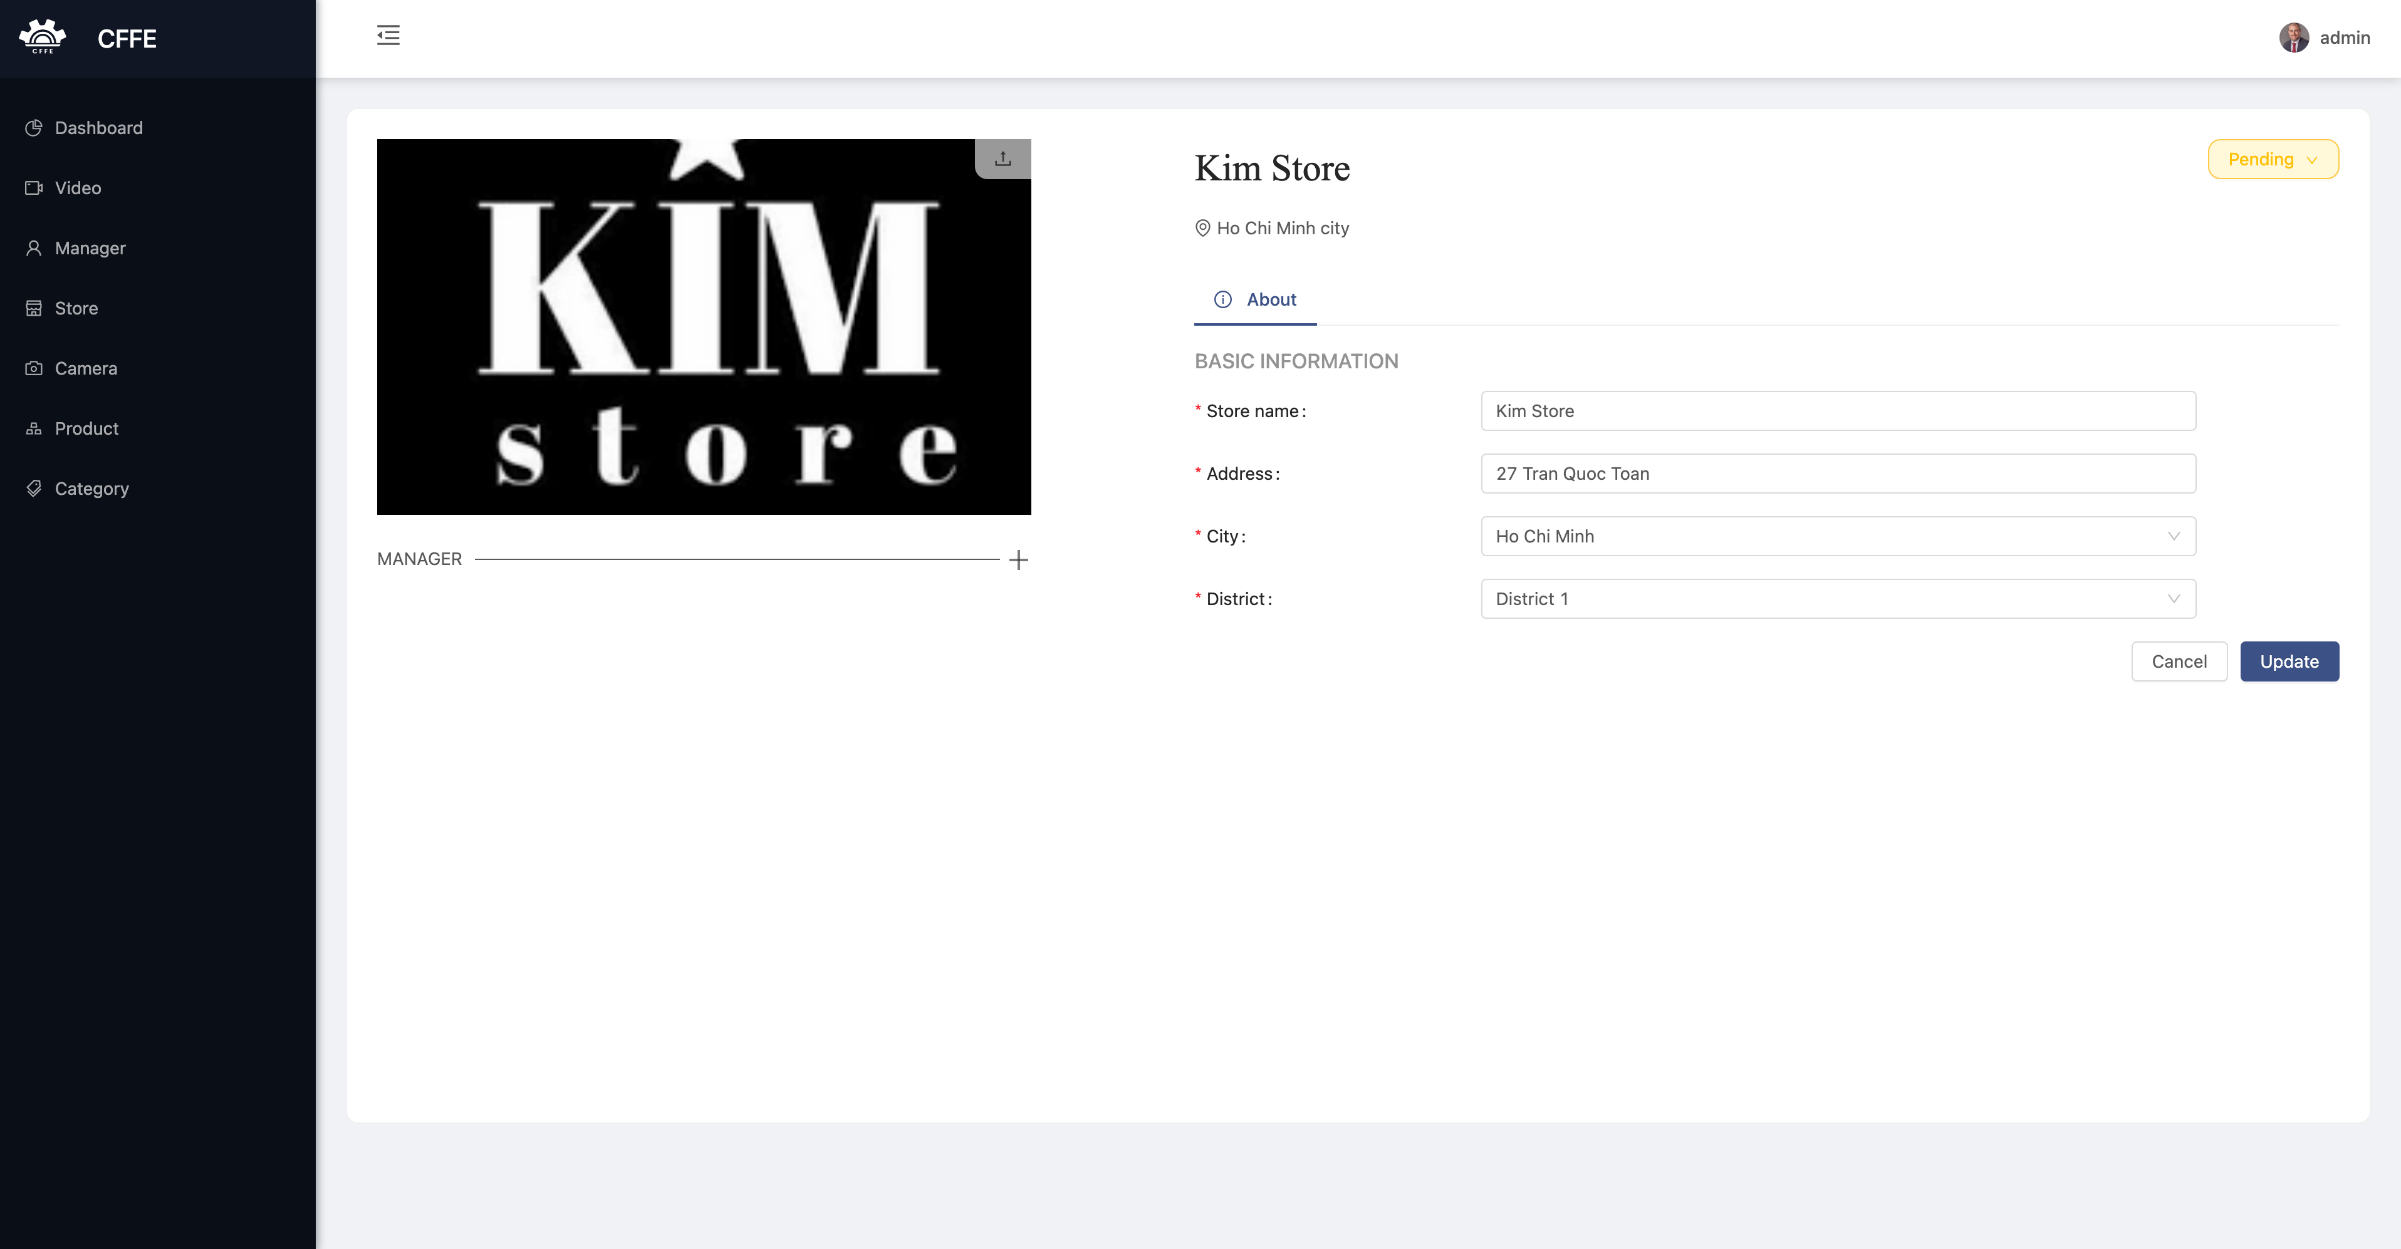

3

2

1

|  |  |
| --- | --- |
| **Step** | **Description** |
| 1 | Admin edits the necessary information of the store. |
| 2 | Admin clicks “Cancel” button to cancel the command. |
| 3 | Admin clicks “Update” button to update the store information. |

4. Add a manager into the store

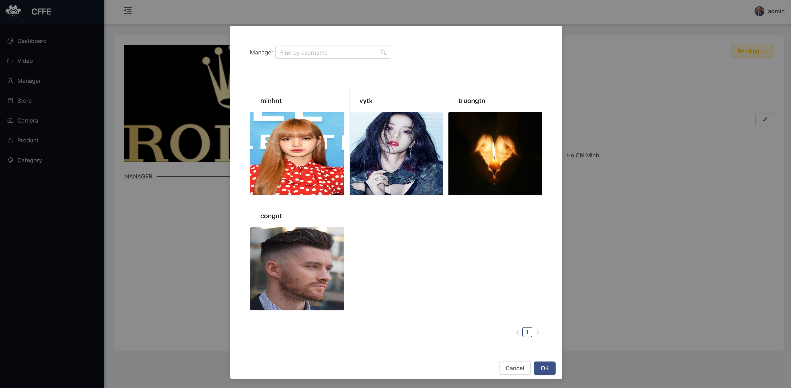

4

3

1

2

|  |  |
| --- | --- |
| **Step** | **Description** |
| 1 | Admin inputs a search value to find by username. |
| 2 | Admin chooses a store in the available list. |
| 3 | Admin clicks “Cancel” button to cancel the command. |
| 4 | Admin clicks “Ok” button to authorize the manager from the store. |

5. Remove the manager from the store

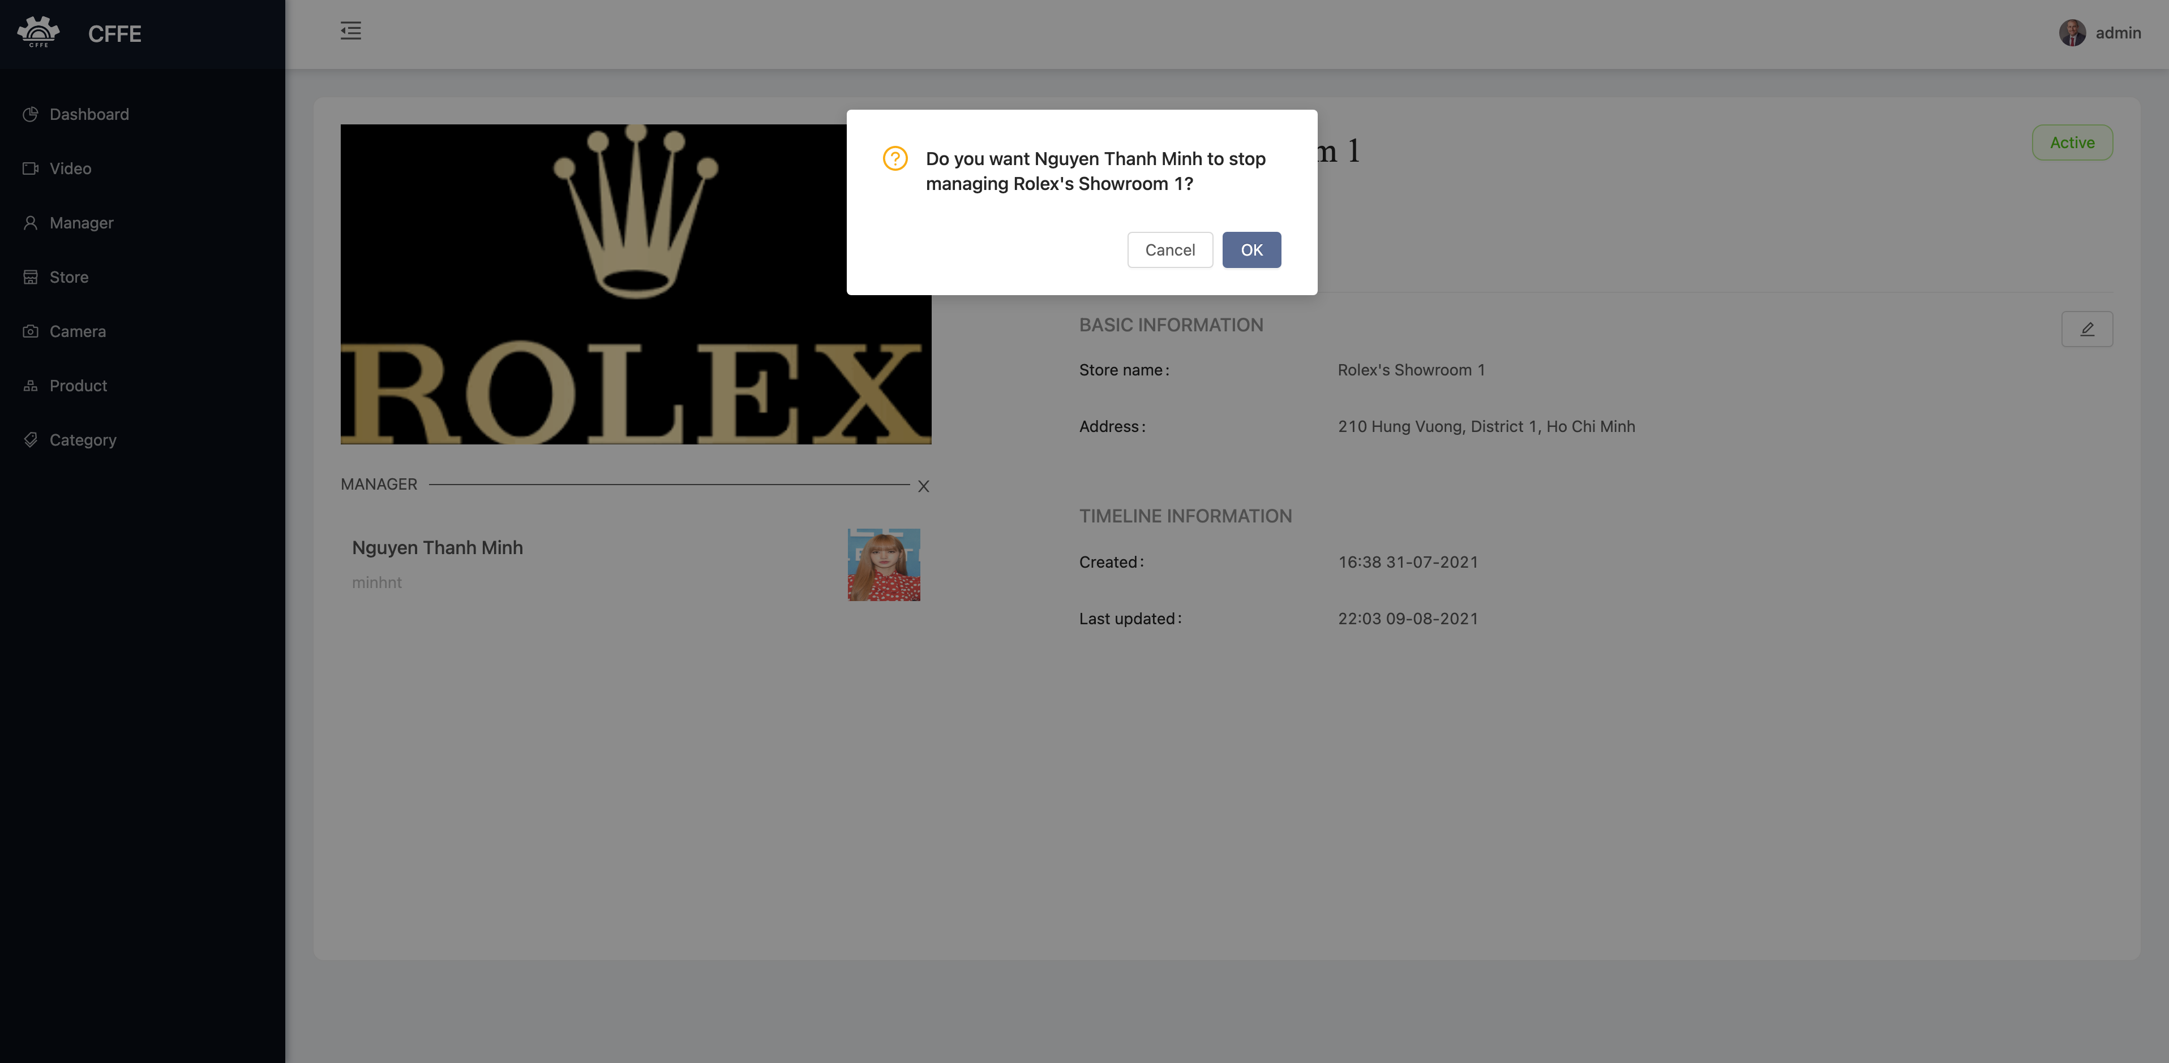

2

1

|  |  |
| --- | --- |
| **Step** | **Description** |
| 1 | Admin clicks “Cancel” button to cancel the command. |
| 2 | Admin clicks “Ok” button to remove the manager from the store. |

**f. Camera page**

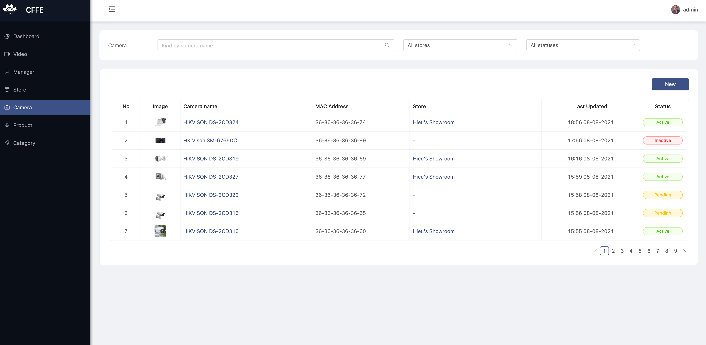

6

5

4

3

2

1

|  |  |
| --- | --- |
| **Step** | **Description** |
| 1 | Admin inputs a search value to find by camera name. |
| 2 | Admin chooses a filter which is all stores or a store name in the dropdown list. |
| 3 | Admin chooses a filter which is all statuses, active, pending or inactive. |
| 4 | Admin clicks “New” button to create a new camera. |
| 5 | Admin clicks a camera name to view camera detail. |
| 6 | Admin clicks a store name to view store detail. |

2. Create a new camera

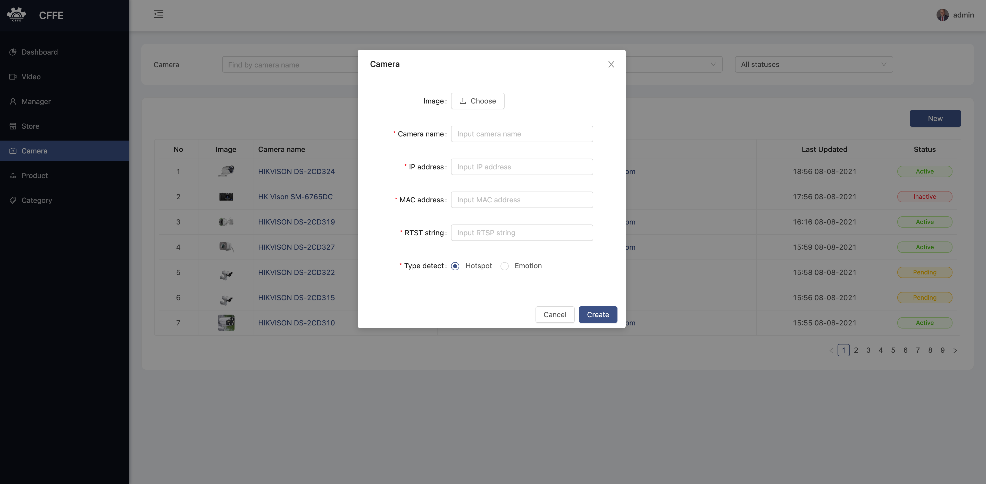

4

3

2

1

|  |  |
| --- | --- |
| **Step** | **Description** |
| 1 | Admin clicks the close button to close the pop up. |
| 2 | Admin enters camera information. |
| 3 | Admin clicks “Cancel” button to cancel the command |
| 4 | Admin clicks “Ok” button to create a new camera. |

**g. Camera detail**

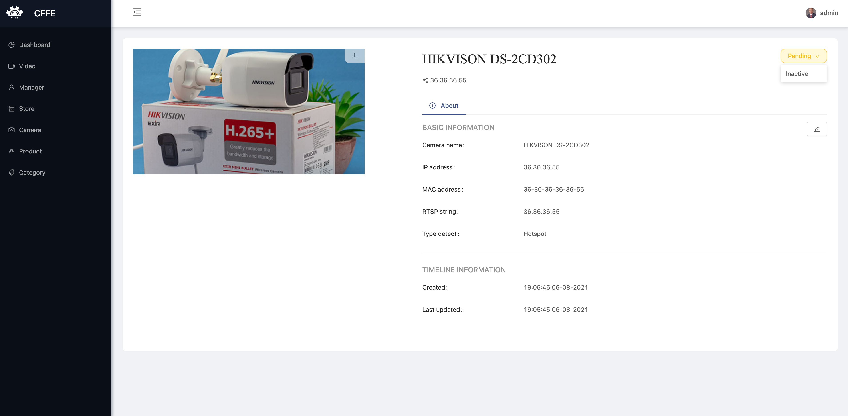

4

3

2

1

|  |  |
| --- | --- |
| **Step** | **Description** |
| 1 | Admin clicks the icon to change the camera avatar. |
| 2 | Admin clicks “Pending” button to show “Inactive” button. |
| 3 | Admin clicks the button to delete the camera. |
| 4 | Admin clicks the icon to update the camera information. |

1. Change the camera avatar.

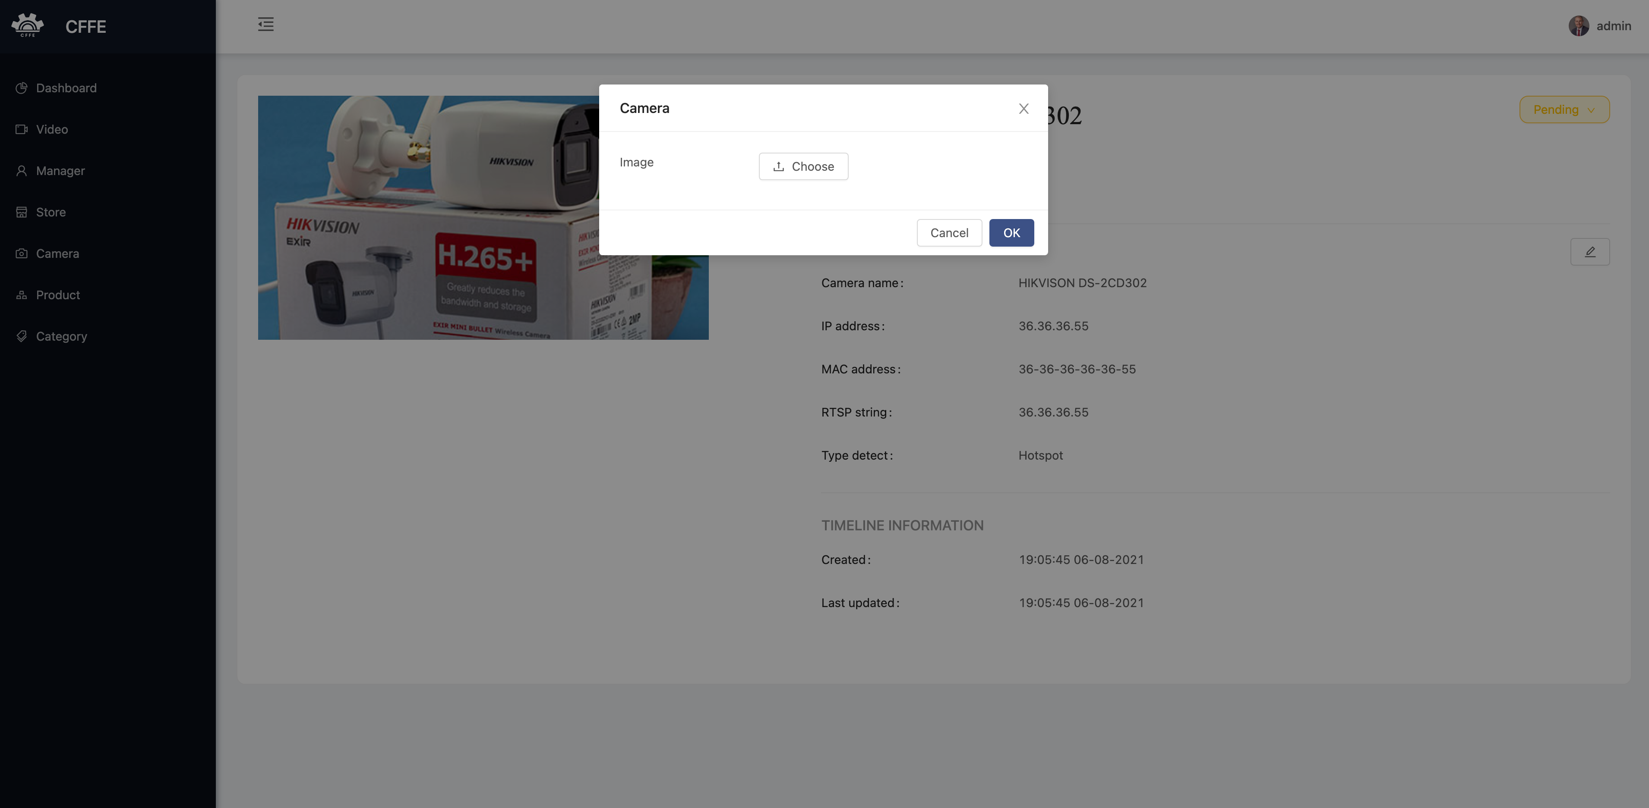

4

3

1

2

|  |  |
| --- | --- |
| **Step** | **Description** |
| 1 | Admin clicks the icon to close the popup. |
| 2 | Admin clicks the button to choose the camera avatar from own computer. |
| 3 | Admin clicks “Cancel” button to cancel the command |
| 4 | Admin clicks “Ok” button to change the camera avatar. |

2. Delete the camera

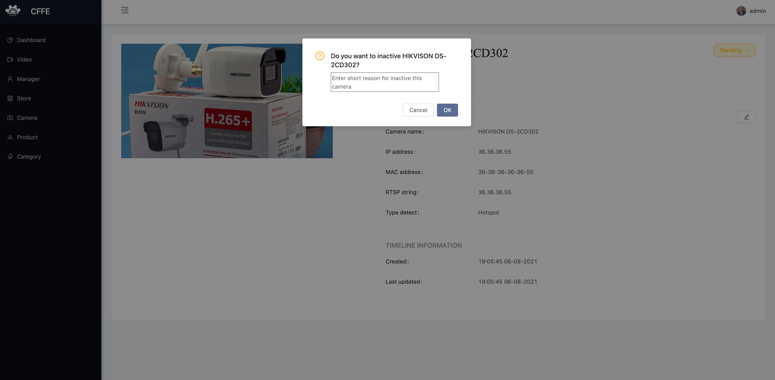

3

1

2

|  |  |
| --- | --- |
| **Step** | **Description** |
| 1 | Admin inputs an inactive reason. |
| 2 | Admin clicks “Cancel” button to cancel the command |
| 3 | Admin clicks “Ok” button to delete the camera. |

3. Update the camera information

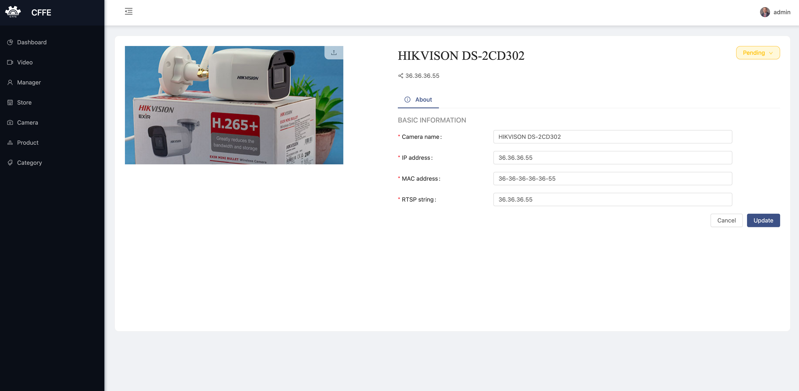

3

2

1

|  |  |
| --- | --- |
| **Step** | **Description** |
| 1 | Admin edits the necessary information of the camera. |
| 2 | Admin clicks “Cancel” button to cancel the command. |
| 3 | Admin clicks “Update” button to update the camera information. |

**h. Product page**

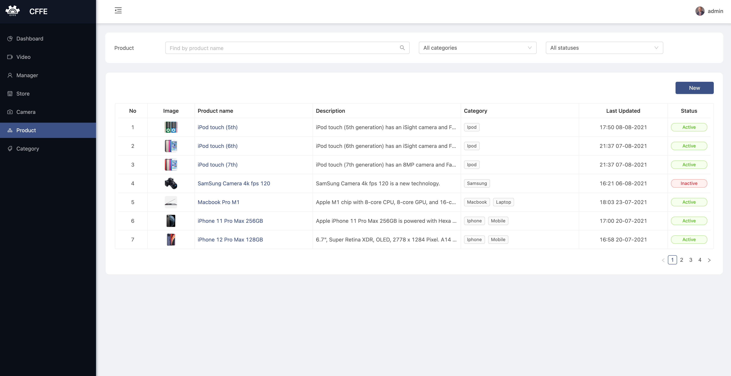

5

4

3

1

2

|  |  |
| --- | --- |
| **Step** | **Description** |
| 1 | Admin inputs a search value to find by product name. |
| 2 | Admin chooses a filter which is all categories or a category in the dropdown list. |
| 3 | Admin chooses a filter which is all statuses, active or inactive. |
| 4 | Admin clicks “New” button to create a new product. |
| 5 | Admin clicks a camera name to view camera detail. |

1. Create a new product

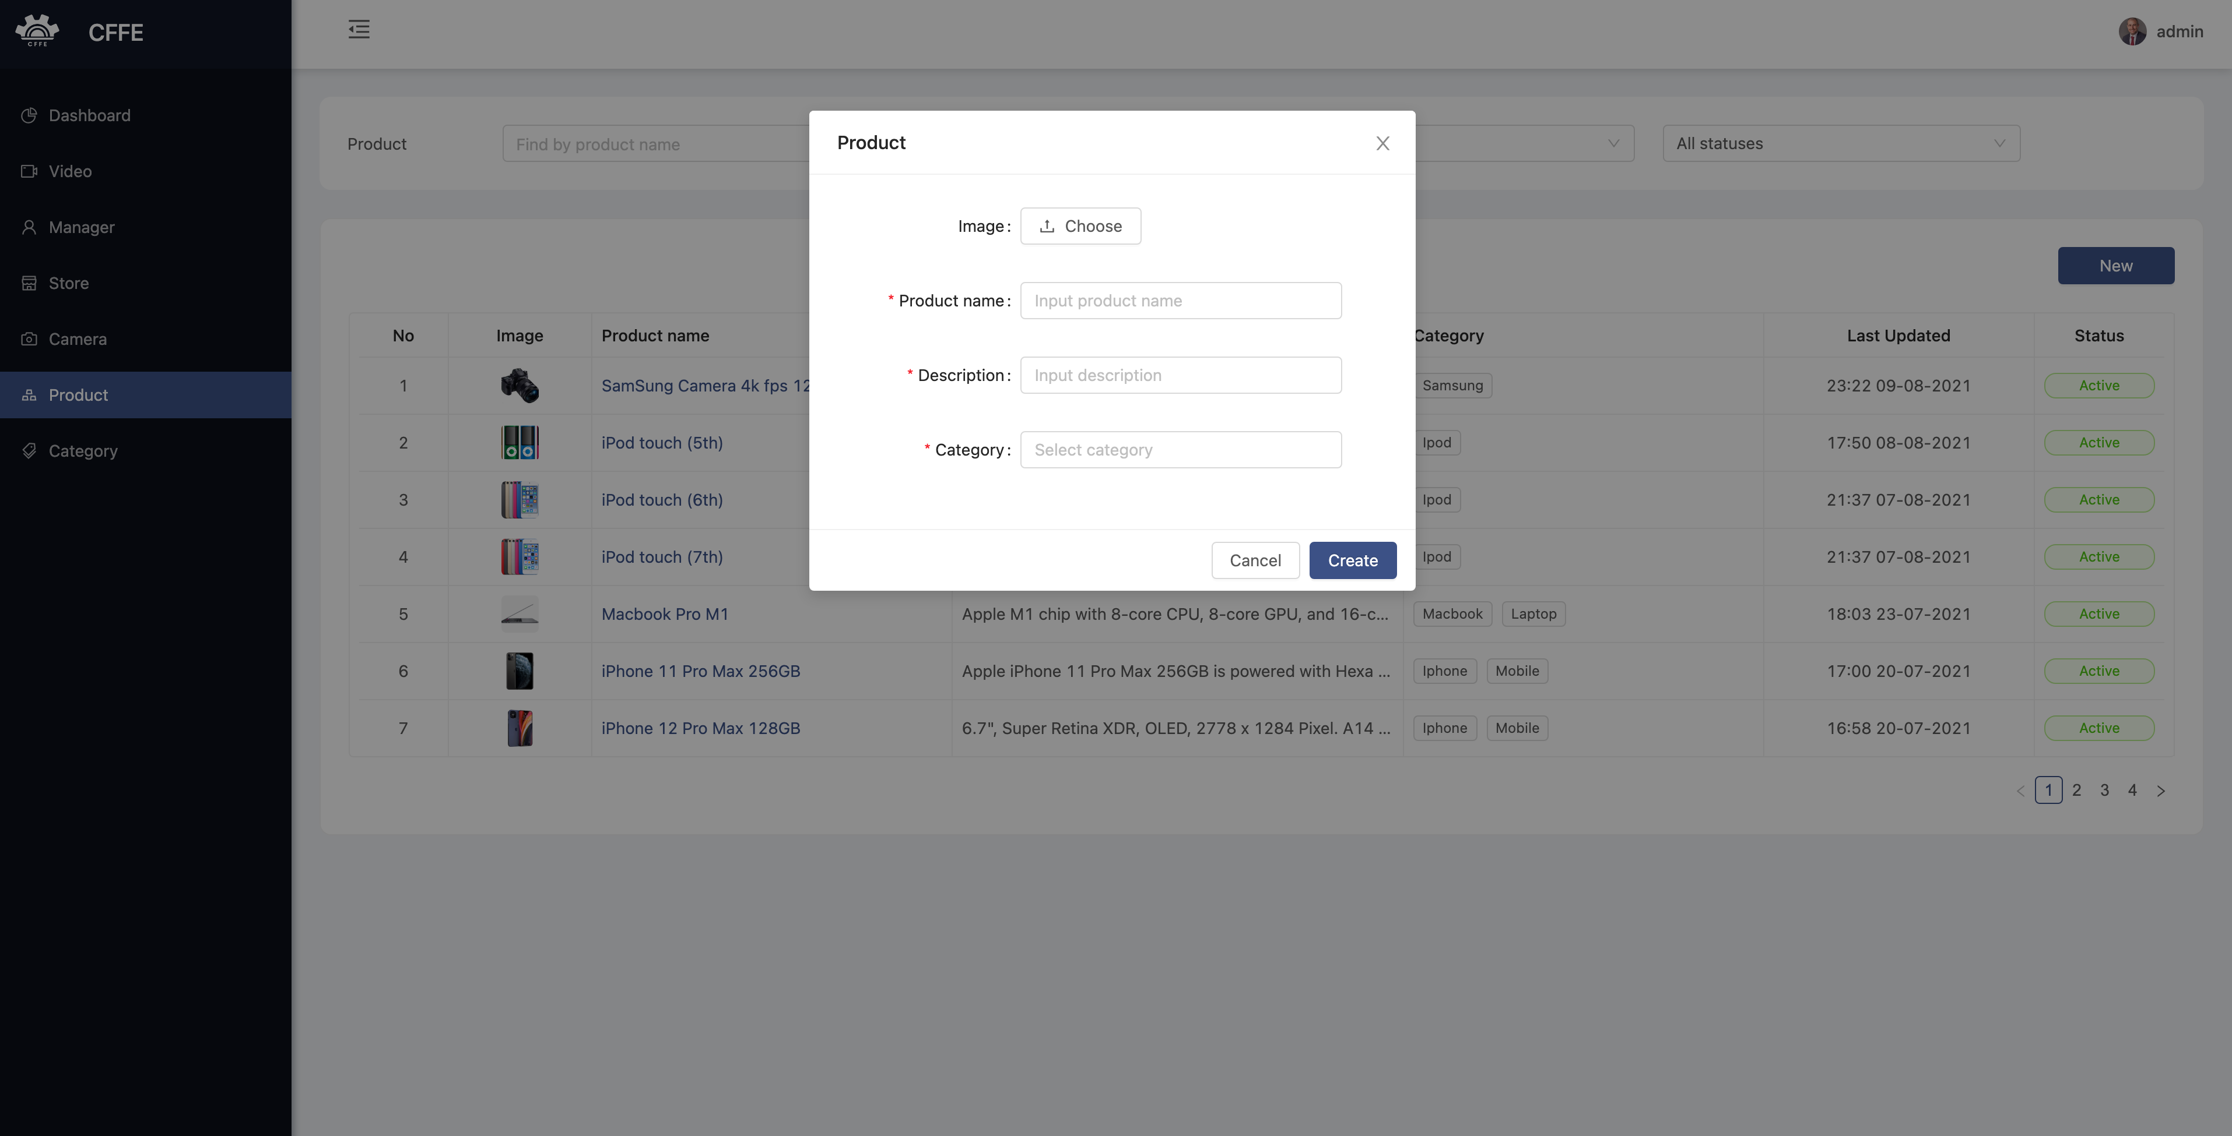

3

4

1

2

|  |  |
| --- | --- |
| **Step** | **Description** |
| 1 | Admin clicks the close button to close the pop up. |
| 2 | Admin enters product information. |
| 3 | Admin clicks “Cancel” button to cancel the command |
| 4 | Admin clicks “Ok” button to create a new product. |

**i. Product detail page**

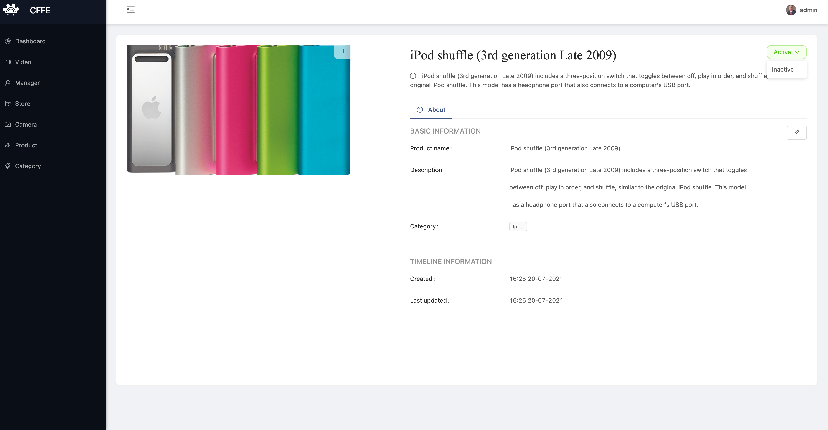

4

2

3

1

|  |  |
| --- | --- |
| **Step** | **Description** |
| 1 | Admin clicks the icon to change the product avatar. |
| 2 | Admin clicks “Active” button to show “Inactive” button. |
| 3 | Admin clicks the button to delete the product. |
| 4 | Admin clicks the icon to update the product information. |

1. Change the product avatar.

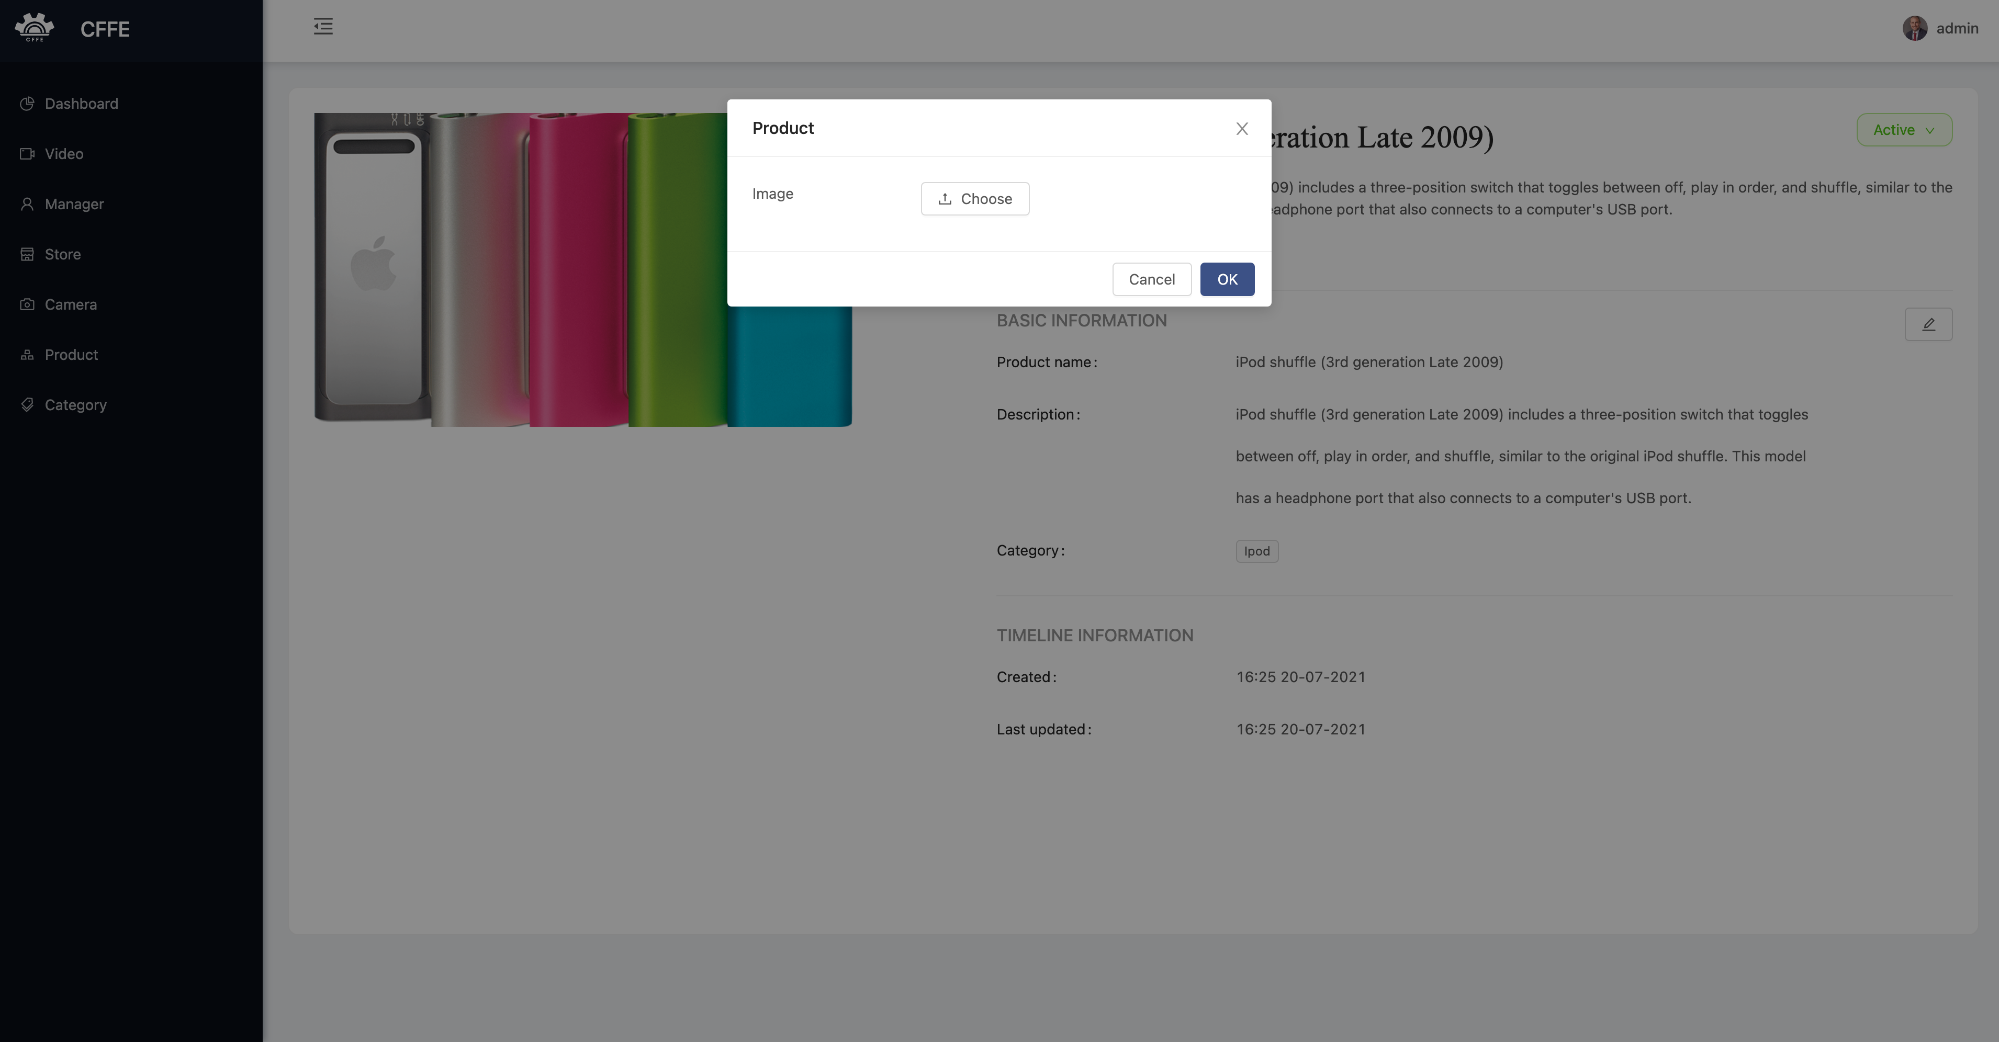

4

3

2

1

|  |  |
| --- | --- |
| **Step** | **Description** |
| 1 | Admin clicks the icon to close the popup. |
| 2 | Admin clicks the button to choose the product avatar from own computer. |
| 3 | Admin clicks “Cancel” button to cancel the command |
| 4 | Admin clicks “Ok” button to change the product avatar. |

2. Delete the product

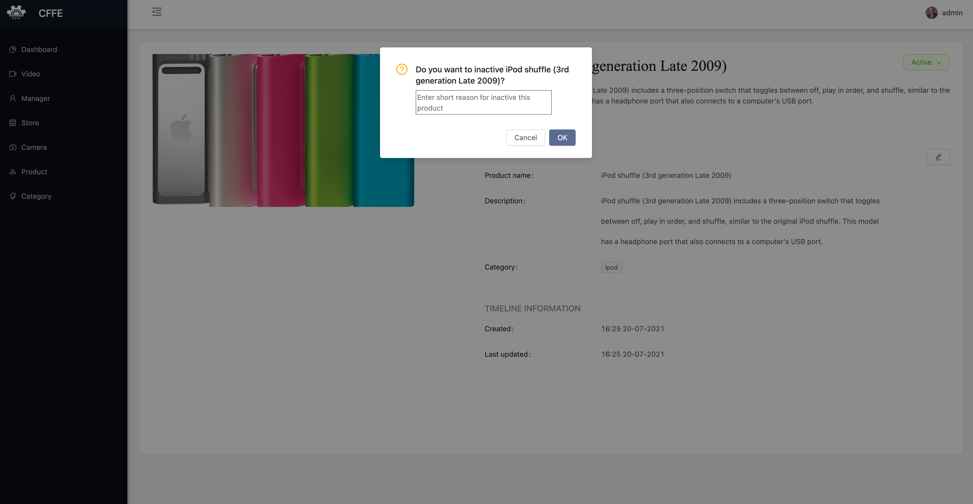

3

2

1

|  |  |
| --- | --- |
| **Step** | **Description** |
| 1 | Admin inputs an inactive reason. |
| 2 | Admin clicks “Cancel” button to cancel the command |
| 3 | Admin clicks “Ok” button to delete the product. |

#### `3.3.1. CFFE-Manager

**a. Overview**

Application used by admin when want to:

+ Login

+ Logout

+ Manage own profile

+ View statistics

+ View video

+ Manage shelf

+ Manage stack

+ Manage camera

+ Manage product

**b. Login page:**



1

2

|  |  |
| --- | --- |
| **Step** | **Description** |
| 1 | Manager inputs the user. |
| 2 | Manager clicks “Login” button. |

**c. Home page**

**d. Profile page**

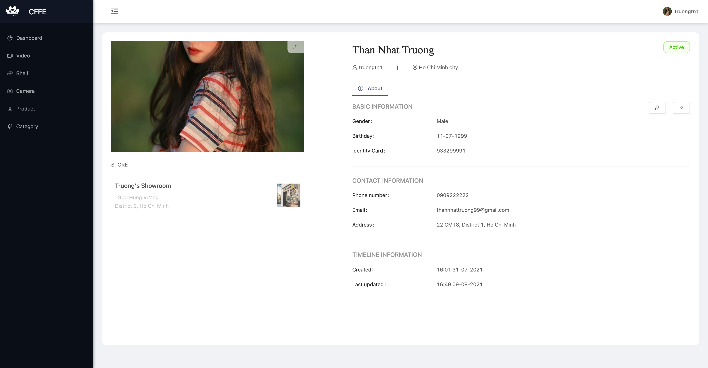

2

3

1

|  |  |
| --- | --- |
| **Step** | **Description** |
| 1 | Manager clicks the icon to change own avatar. |
| 2 | Manager clicks the icon to change own password. |
| 3 | Manger clicks the icon to update own information. |

1. Change own avatar.

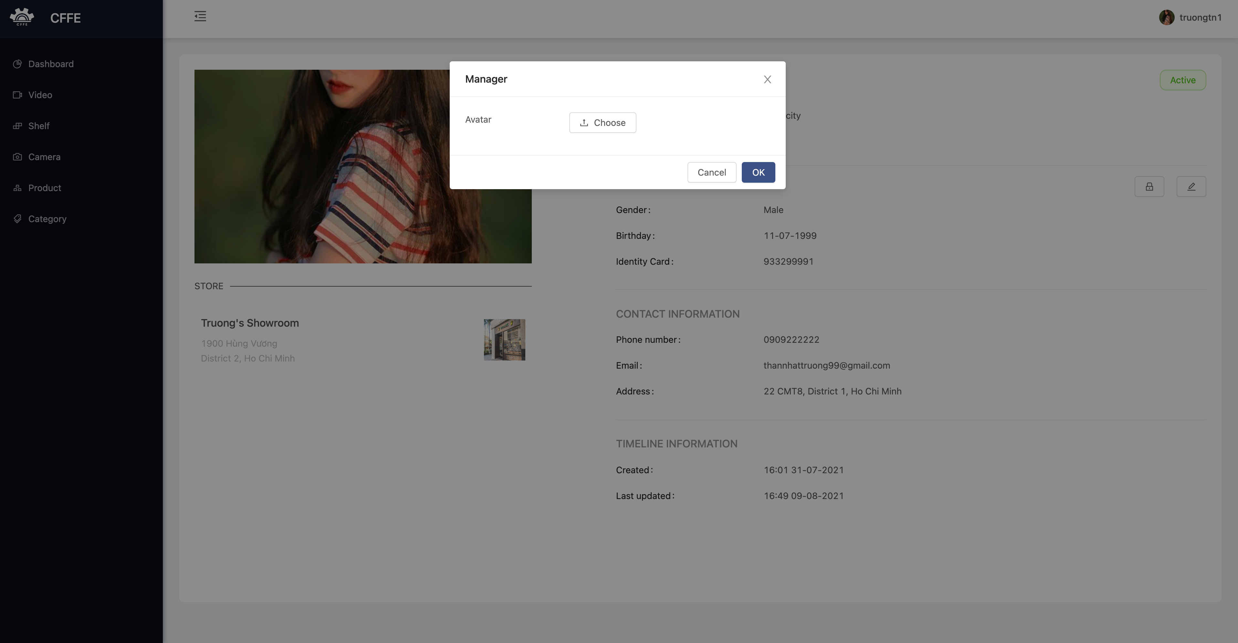

4

3

2

1

|  |  |
| --- | --- |
| **Step** | **Description** |
| 1 | Manager clicks the icon to close the popup. |
| 2 | Manager clicks the button to choose an avatar from own computer. |
| 3 | Manager clicks “Cancel” button to cancel the command |
| 4 | Manager clicks “Ok” button to change own avatar. |

2. Change own password

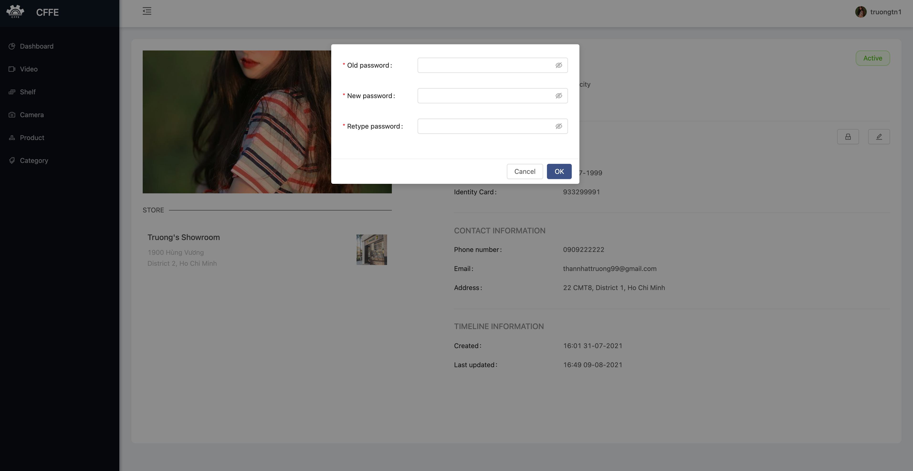

4

5

2

1

3

|  |  |
| --- | --- |
| **Step** | **Description** |
| 1 | Manager inputs own old password. |
| 2 | Manager inputs own new password. |
| 3 | Manager inputs own re-type password |
| 4 | Manager clicks “Cancel” button to cancel the command |
| 5 | Manager clicks “Ok” button to change own password. |

3. Update own information

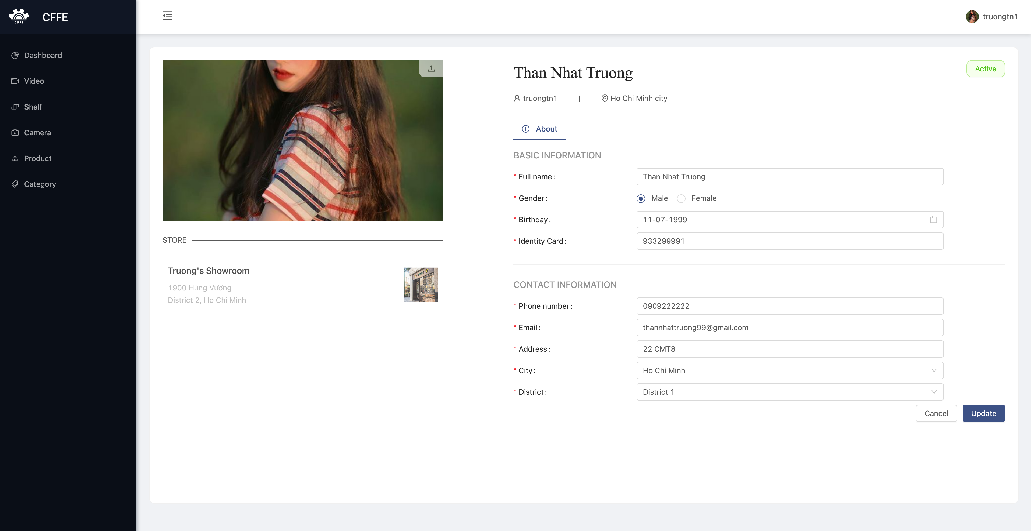

3

2

1

|  |  |
| --- | --- |
| **Step** | **Description** |
| 1 | Manager edits the necessary information. |
| 2 | Manager clicks “Cancel” button to cancel the command. |
| 3 | Manager clicks “Update” button to update own information |

e. Video page

f. Shelf page

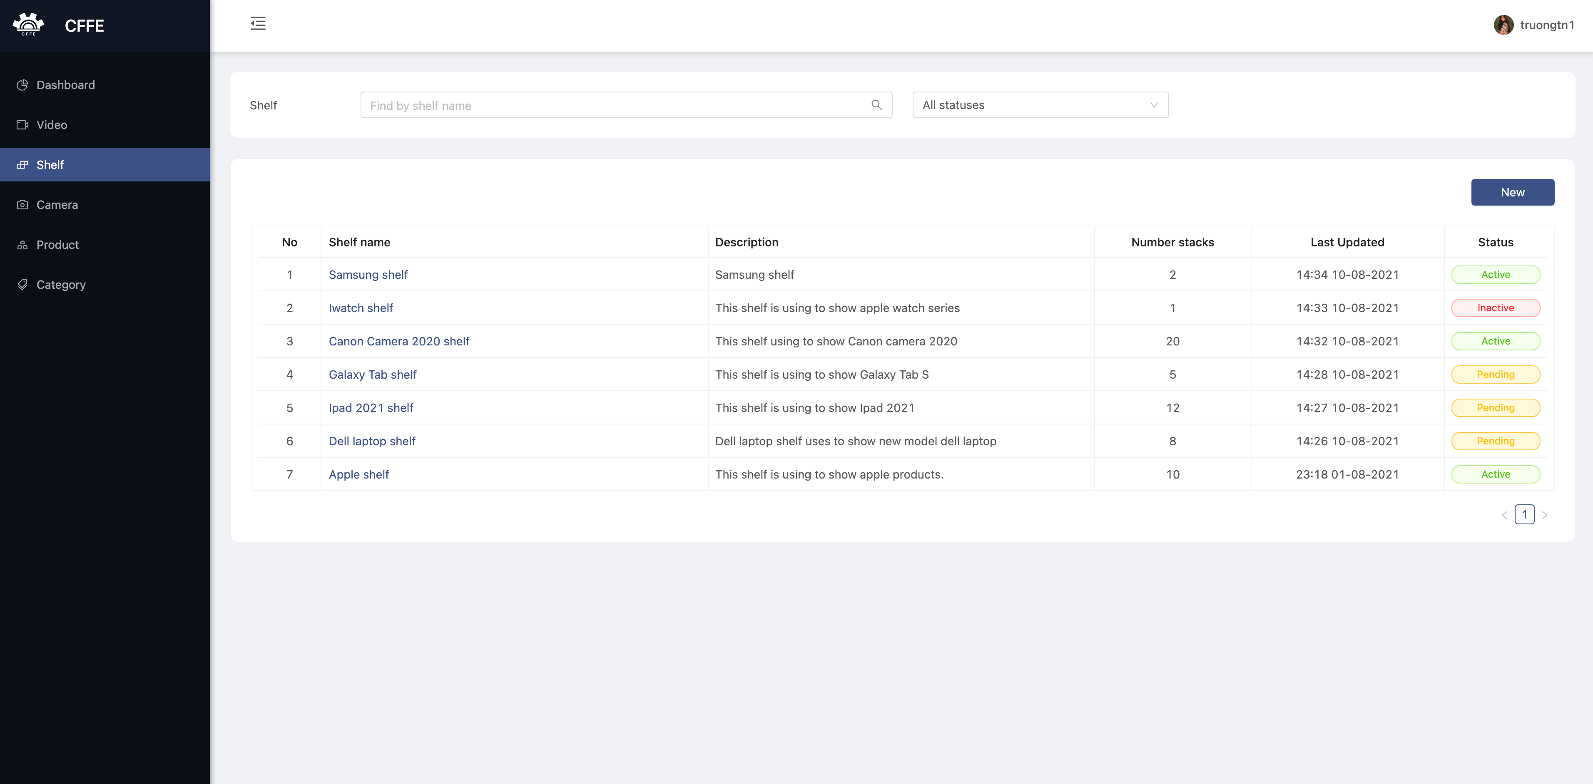

4

3

2

1

|  |  |
| --- | --- |
| **Step** | **Description** |
| 1 | Manager inputs a search value to find by shelf name. |
| 2 | Manager chooses a filter which is all statuses, active, pending or inactive. |
| 3 | Manager clicks “New” button to create a new shelf. |
| 4 | Manager clicks a shelf name to view shelf detail. |

1. Create a new shelf

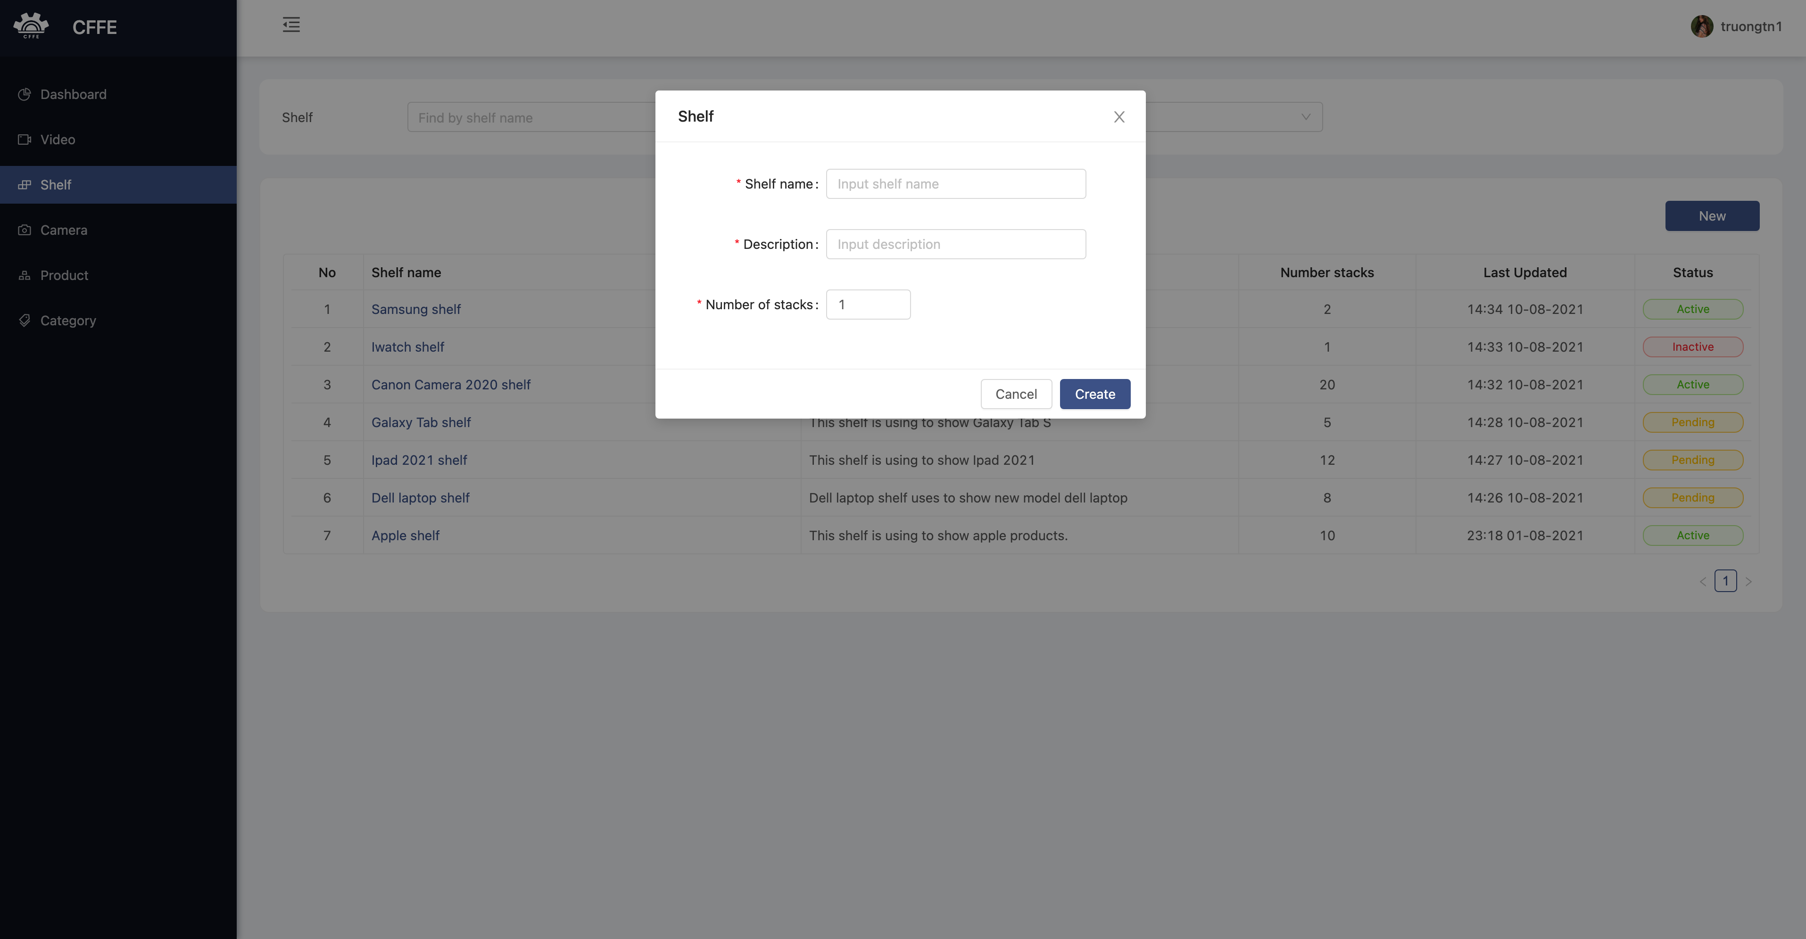

4

3

2

1

|  |  |
| --- | --- |
| **Step** | **Description** |
| 1 | Manager clicks the close button to close the pop up. |
| 2 | Manager enters shelf information. |
| 3 | Manager clicks “Cancel” button to cancel the command |
| 4 | Manager clicks “Ok” button to create a new shelf. |

**g. Shelf detail**

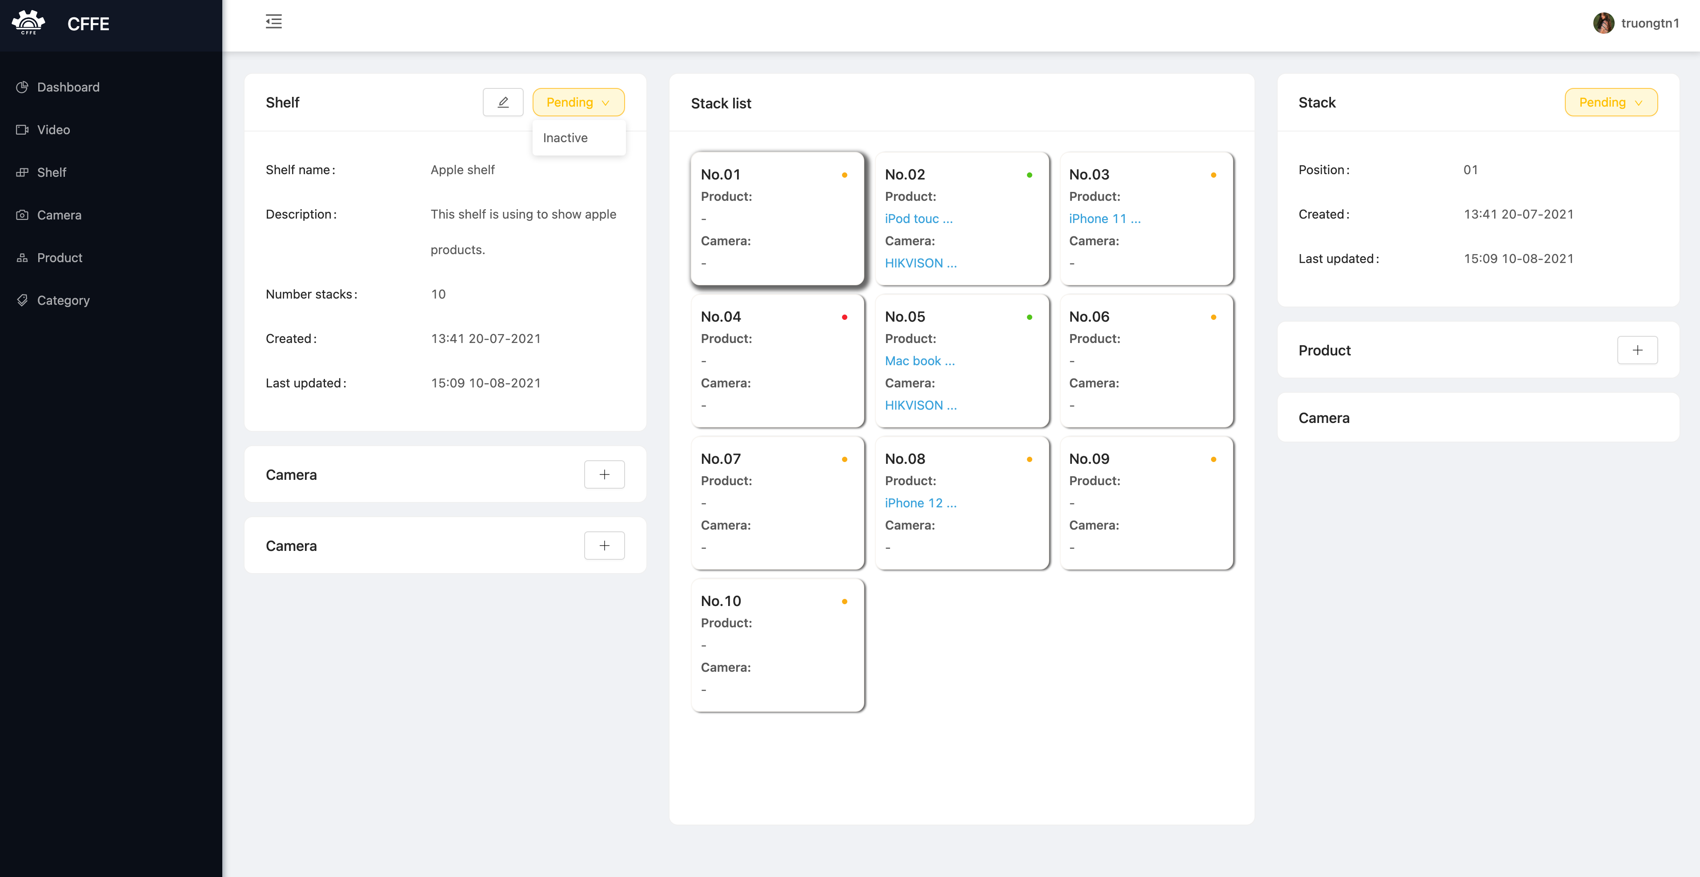

6

7

5

4

3

1

2

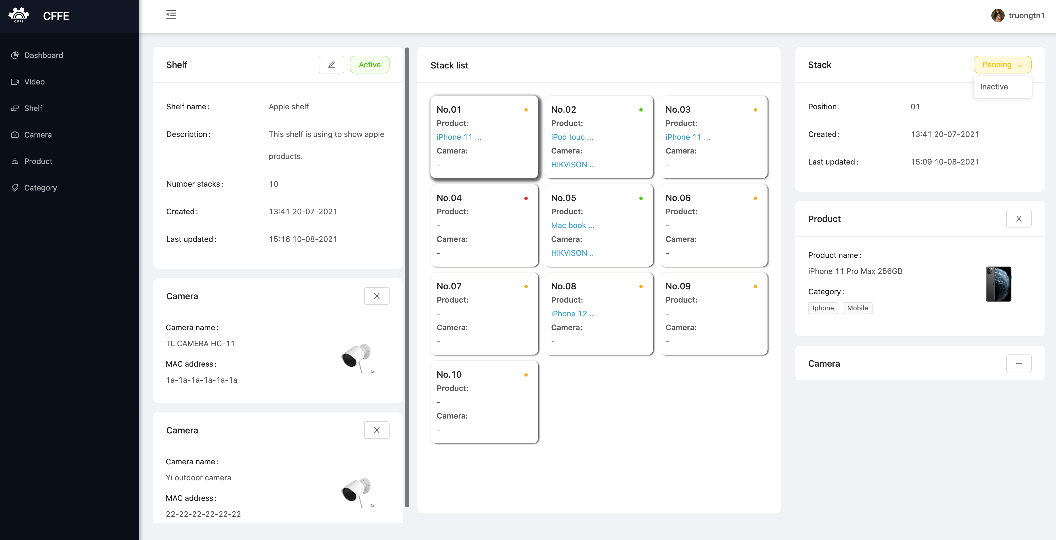

10

13

12

11

9

8

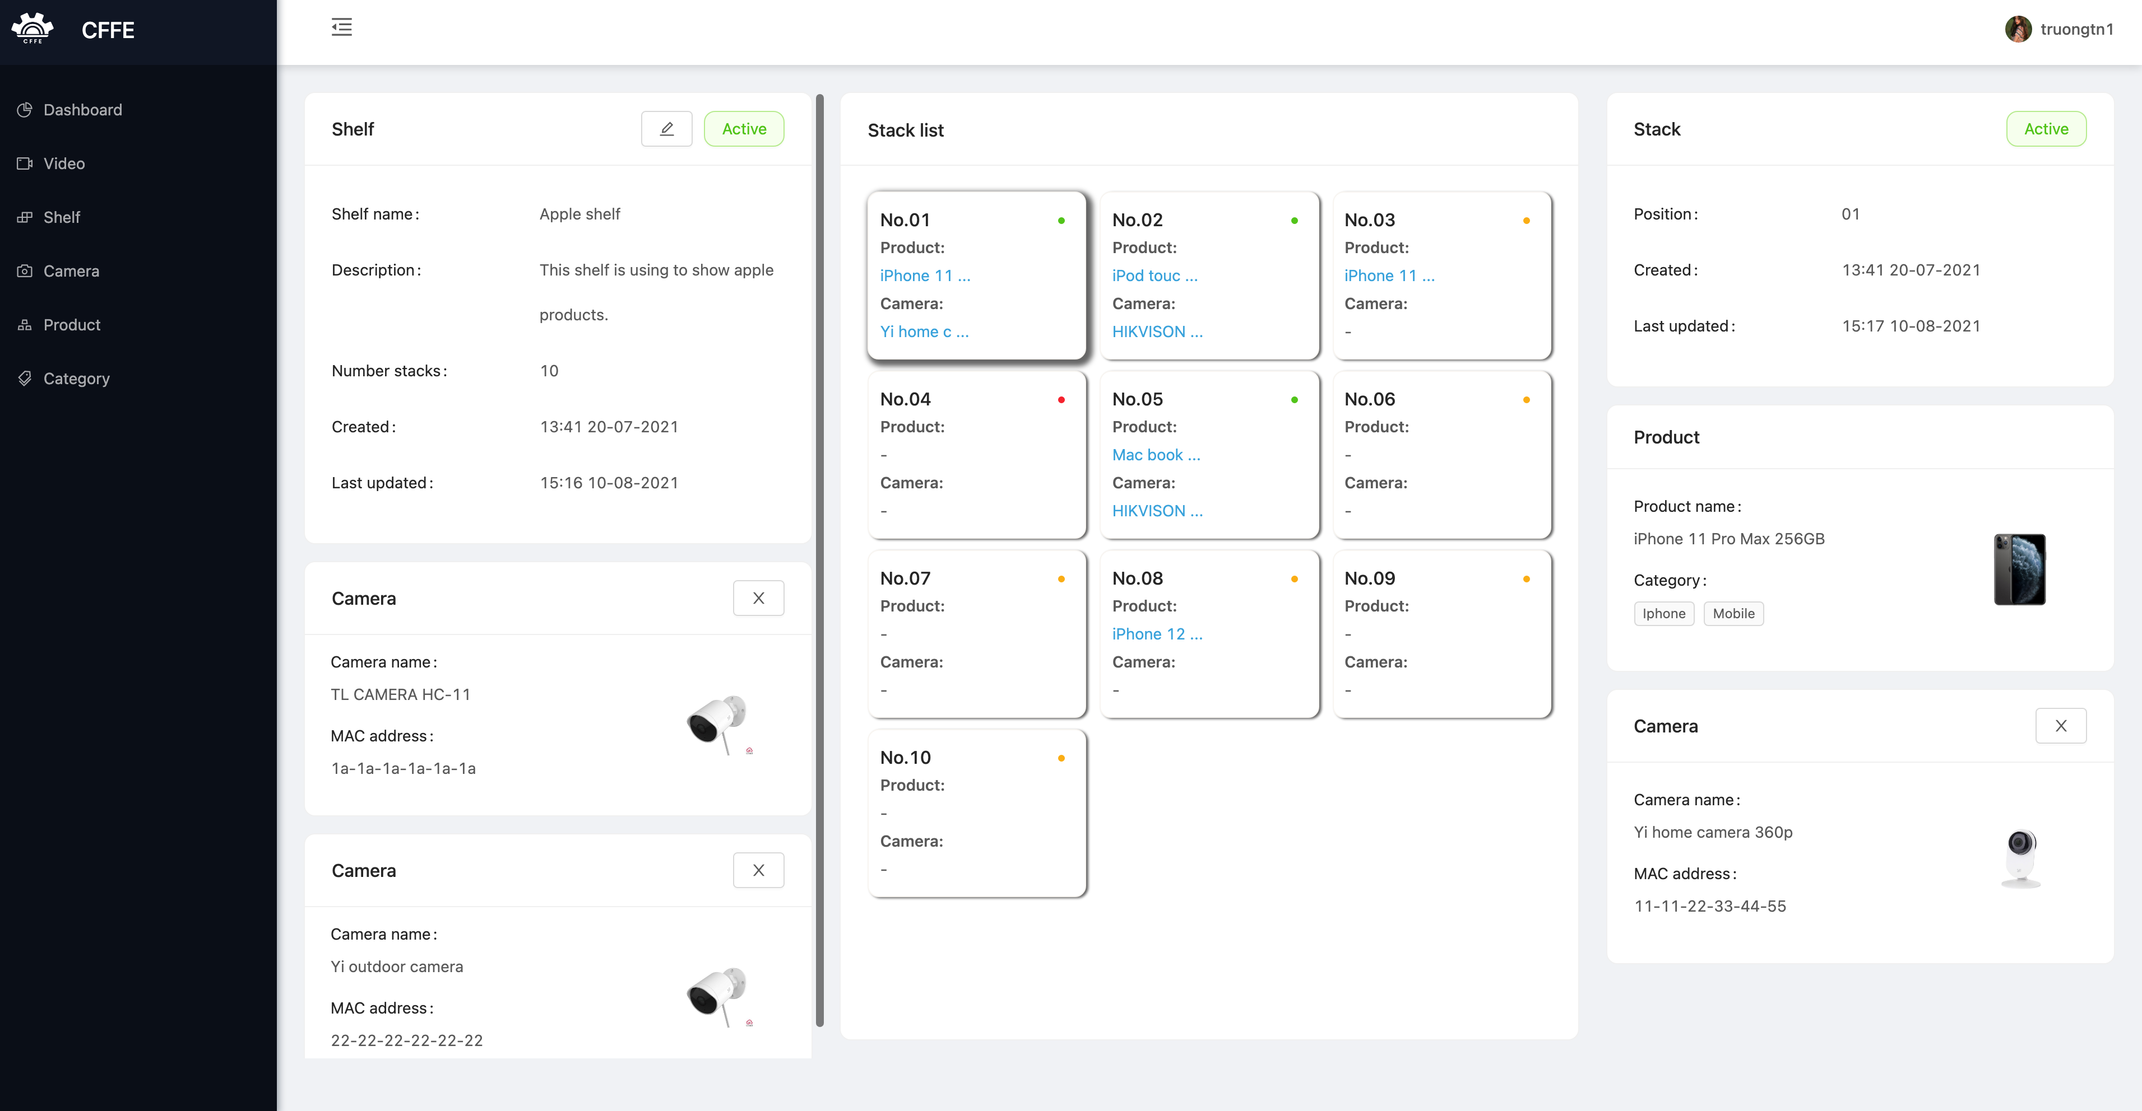

14

|  |  |
| --- | --- |
| **Step** | **Description** |
| 1 | Manager clicks the icon to update the shelf information. |
| 2 | Manager clicks “Pend” button to show “Inactive” button. |
| 3 | Manager clicks the button to delete the shelf. |
| 4 | Manager clicks the box to view the stack detail. |
| 5 | Manager clicks the icon to add a camera into the shelf. |
| 6 | Manager clicks the icon to add a camera into the shelf. |
| 7 | Manager clicks the icon to add a product into the stack. |
| 8 | Manager clicks the icon to remove the camera from the shelf. |
| 9 | Manager clicks the icon to remove the camera from the shelf. |
| 10 | Manager click “Pending” button |
| 11 |  |
| 12 |  |
| 13 |  |
| 14 |  |